

FACULTY OF SCIENCE & TECHNOLOGY

BSc (Hons) Software Engineering
May 2021

Ethics of Monetisation in Digital Games

by

Elowen Wilkinson

Faculty of Science & Technology
Department of Computing and Informatics
Final Year Project

Abstract

Digital game publishers currently employ a wide array of additional monetisation techniques – i.e., techniques to increase revenue past the point of entry – in their games, but they are often unclear about which monetisation techniques appear in their games and what that means for a customer. This has led to serious allegations from the public and academia that game publishers are exploiting their customers for the sake of profit using predatory monetisation techniques.

This project aims to improve ethics in the digital games industry by increasing transparency to help consumers protect themselves from or at least inform themselves of the various monetisation strategies employed by the games they play.

This aim was achieved by developing a prototype for an app that will allow a user to look up games and see which additional monetisation techniques are employed by that game. This means consumers with increased vulnerability to additional monetisation techniques, such as minors or those with an increased vulnerability to gambling, can avoid potentially dangerous monetisation techniques.

The prototype was developed using established industry app development practices according to well-known project management and software development methodologies and was built with the assistance of volunteer survey participants and software testers.

This prototype can serve as a proof of the concept of a public information app about games monetisation – the reception of the prototype certainly seems to suggest that such an app would be well used. Hopefully, the work in this project will serve as the basis for a fully released mobile app that can be used to inform consumers on additional monetisation in games.

Dissertation Declaration

I agree that, should the University wish to retain it for reference purposes, a copy of my dissertation may be held by Bournemouth University normally for a period of 3 academic years. I understand that once the retention period has expired my dissertation will be destroyed.

Confidentiality

I confirm that this dissertation does not contain information of a commercial or confidential nature or include personal information other than that which would normally be in the public domain unless the relevant permissions have been obtained. In particular any information which identifies a particular individual's religious or political beliefs, information relating to their health, ethnicity, criminal history or sex life has been anonymised unless permission has been granted for its publication from the person to whom it relates.

Copyright

The copyright for this dissertation remains with me.

Requests for Information

I agree that this dissertation may be made available as the result of a request for information under the Freedom of Information Act.


Signed: .

Name: Elowen Wilkinson

Date: 25/05/2021

Programme: Software Engineering

Original Work Declaration

This dissertation and the project that it is based on are my own work, except where stated, in accordance with University regulations.


Signed: .

Name: Elowen Wilkinson

Date: 25/05/2021

Acknowledgments

This project would not have been possible without the tremendous amount of support and assistance that has been provided to me. First and foremost I would like to thank Dr. Deniz Cetinkaya, my supervisor, for her patience and constant guidance as well as her assistance in formulating the research question and core subject of the project.

I would also like to thank those who participated in the survey that was conducted as part of the project – the input received was invaluable, and without your help this project would have been far weaker. In addition, I would particularly like to thank the four survey participants who subsequently agreed to assist in testing the artefact once it was developed. Your assistance was invaluable and your perspectives absolutely vital. Unfortunately, these four all declined to be thanked by name.

Thanks to Alicia James, who proof-read my work; your discerning eye was much appreciated.

I extend my thanks too to all my friends and family who supported me throughout my academic career, particularly my parents, without whom I would not be here today.

Finally, I would like to thank Nicola Purches-Knab, my former lecturer at Truro College who provided my first insights into the study of ethics and philosophy as an academic discipline.
TABLE OF CONTENTS
1 INTRODUCTION 12
1.1 Terms and Definitions 12
1.2 Background 12
1.3 Problem Definition and Research Question 13
1.4 Rationale and Motivation 13
1.5 Aims and Objectives 13
1.5.1 Objectives 14
1.6 Success Criteria per Objective 15
1.7 Chapter Overview 15
2 LITERATURE SURVEY AND BACKGROUND STUDY 17
2.1 Literature Survey: On the Ethics of Additional Monetisation in the Digital Games Industry 17
2.1.1 Introduction 17
2.1.2 Psychological Impact 18
2.1.3 Philosophical Perspectives 19
2.1.4 Conclusion: A Technological Solution to a Social Issue 20
2.2 Related Work 21
2.2.1 Approach 21
2.2.2 Ratings Board Apps Comparison & Lessons Learnt 22
3 METHODOLOGY 26
3.1 Project Management 26
3.2 Research and Development 27
4 ANALYSIS 28
4.1 Survey Results 28
4.1.1 Player Demographics and Spending 29
4.1.2 Knowledge of Additional Monetisation 29
4.1.3 Opinions of the Game Industry and Monetisation Strategies 30
4.1.4 Gambling 33
4.1.5 Survey Conclusions 33
4.2 Specification 35
4.2.1 Scope 35
4.2.2 Description 35
4.2.3 User Needs 35
4.3 Functional Requirements 36
4.3.1 Must Have Features: 36
4.3.2 Should Have Features: 36
4.3.3 Could Have Features: 36
4.3.4 Won’t Have Features: 37
4.3.5 Table of Functional Requirements 37
4.4 Non-functional Requirements 38
4.4.1 Table of Non-functional Requirements 38

5 DESIGN 39
5.1 Categorising Monetisation Strategies 39
5.2 Front-end Designs 40
5.2.1 Games List Screen 40
5.2.2 Game Information Screen 41
5.2.3 Monetisation 42
5.2.4 Ratings Explained 43
5.2.5 User Guide 44
6 IMPLEMENTATION 45
6.1 Core Frameworks, Runtime Environment, and Software 45
6.2 React Navigation 45
6.3 Database Selection 46
6.3.1 Internet Game Database 47
6.3.2 RAWG Database 47
6.3.3 Giant Bomb Database 47
6.4 Data Retrieval 48
6.5 Games List Screen 49
6.6 Game Information Screen 53
6.7 Other Screens 57
7 EVALUATION 58
7.1 User Testing Design 58
7.2 Evaluation Execution 59
7.3 Tester Findings 59
7.3.1 Fitness for Purpose 59
7.3.2 Bugs 59
7.3.3 User Experience 59
7.3.4 Potential 60
7.4 Researcher Evaluation 60
7.4.1 Objectives 60
7.4.2 Requirements 62
8 CONCLUSION & FUTURE WORK 64
REFERENCES 67
APPENDIX A – PROPOSAL AND ORIGINAL PLAN 72
APPENDIX B – RESEARCH ETHICS CHECKLIST 77
APPENDIX C – INTERIM PROGRESS REPORT 82
APPENDIX D – DEFINITIONS AND TERMS 83
APPENDIX E – RATINGS BOARD RATINGS 84
ESRB Rating Categories 84
PEGI Age Ratings 85
Content Descriptors 87
APPENDIX F – SURVEY QUESTIONS AND RESULTS 90
APPENDIX G – USER TESTING FINDINGS 106
Q3 107
APPENDIX H – LARGE FILE CONTENTS 114

LIST OF FIGURES
Figure 1: A comparison of the home screens of the ratings board apps. 21
Figure 2: A comparison of the navigation menus. 22
Figure 3: A comparison of the two screens displaying ratings categories. 24
Figure 4: The Kanban board that was used for this project. 25
Figure 5: None of the participants said they bought fewer than three games a year on average.... 28
Figure 6: Participants’ general opinions of the state of information in the games industry… 29
Figure 7: Most participants felt that microtransactions negatively impacted the game… 30
Figure 8: Most participants felt that they improved the game experience… 31
Figure 9: The mock-up for the games list screen of the prototype. 39
Figure 10: The mock-up for the Game Information Screen. 40
Figure 11: The Monetisation page 41
Figure 12: The Ratings Explained page 42
Figure 13: The User Guide page 43
Figure 14: Code for the Stack navigator. 45
Figure 15: Code for the “search” Axios request to allow a user to search for a game. 47
Figure 16: The RowCard component in use. 48
Figure 17: The RowCard component code. Stylesheet not pictured. 48
Figure 18: The list of games returned when the API call is made 49
Figure 19: The code for the GamesList screen. 49
Figure 20: The search bar in use on the Games List screen. 50
Figure 21: The search bar code. 51
Figure 22: Search function code. 51
Figure 23: The full finished GamesList page. 52
Figure 24: A sample of the Game Screen when first opened. 53
Figure 25: The monetisation section visible below the game’s description. 54
Figure 26: The code for the VoteButton’s functionality. 55
Figure 27: When tapped, the Report button shows this Alert to the user 56
Figure 28: The prototype’s current Game Rating section. 56
Figure 29: The Games List with the current navigation tabs shown at the bottom. 57

INTRODUCTION
In the last fifteen years, there has been much innovation in the games industry in the field of additional monetisation of premium products. Game publishers are always devising new monetisation schemes and finding ways to increase revenue. In the face of these innovations, the game-buying public has begun to make serious allegations that game publishers are monetising their product in a predatory fashion; this has attracted the attention of academics across several disciplines as well as legislators.

While game publishers are desperate to keep their monetisation schemes running unmolested, psychologists are finding that many such schemes have great potential for harm to vulnerable individuals, causing other academics to examine their ethical implications. Researchers from many disciplines are now advocating for additional monetisation in games to be regulated.

Terms and Definitions
Throughout the course of the dissertation, specialised language related to the field of monetisation in digital games will be used. Please see Appendix D for details.

Background
Before the seventh generation of game consoles, things were simple. The customer purchased a console, purchased their games, and played them. These games were feature complete on release, game-breaking bugs were decidedly rare, and if consumers gave more money to a publisher for the same game, it was because they were buying a large expansion pack that came on its own disc full of new content. The first portents of the future that was to come would emerge in 2006 with the start of the seventh generation and the first known micro-transaction to achieve wide-scale public visibility (Williams, 2017): the now-infamous Horse Armor DLC for Bethesda’s The Elder Scrolls IV: Oblivion.

Around this time, some interest in the application of microtransactions was already present – online social spaces like Habbo Hotel and Second Life contained premium content that would now be considered micro-transactions (van Berlo and Liblik, 2016). They were a lucrative business model, and game publishers were paying attention. Ever since, the encroachment of additional monetisation techniques in premium games has been slow but steady, and now there are news stories of children and vulnerable individuals causing financial ruin for themselves or their families (Kleinman, 2019; Thubron, 2017; Cooper, 2020) by having been duped into spending large sums of money on in-game purchases.

Problem Definition and Research Question
Video game publishers are often unclear as to which monetisation techniques are employed in their games and consumers are often unfamiliar with what exactly a particular monetisation strategy means - this opens them to being exploited for profit. Some academics propose regulation to address this, but the law is slow. This problem leads to the research question of this project:
“How can we improve the ethics of additional monetisation in the digital games industry?”

Rationale and Motivation
The increasing usage of additional monetisation in games and the growing number of ways in which it can be employed have long been subjects of academic interest, but recently ever more academics from a range of disciplines are finding that additional monetisation is often predatory. Drummond and Sauer (2018) wrote a journal article finding that loot-boxes were psychologically akin to gambling, and so advocated for tighter regulation on the games industry’s monetisation strategies, and they were not alone in finding monetisation techniques in games exploitative.

While others in the field such as have suggested some solutions, most of the proposed solutions are regulatory in nature, suggesting that the law should force game publishers to behave in a more ethical manner. This is an effective solution, but as powerful a tool as the law is for the protection of citizens from corporate interests, it is also an extremely slow one. This project will therefore attempt to find a way of improving the ethics of monetisation in digital games without relying on regulation.

Aims and Objectives
The project aims to help consumers protect themselves from or at least inform themselves of the various monetisation strategies employed by the games they play.

This will be achieved by the creation of a mobile app prototype as a proof of concept. This prototype will demonstrate how an app can inform users on additional monetisation techniques and where they are used so that they can make well-informed purchasing decisions based on that information. This can serve as an intermediary solution to the ethical issues in the games industry while legislation catches up to technology.

Objectives
To achieve this aim, the following objectives must be accomplished.

- Identify the impact on the player of additional monetisation in digital games and assess the ethics of the practices used by the games industry.

- Research the findings of academics on the impact and ethics of additional monetisation practices in the games industry.

- Design a prototype which is capable of fully informing someone with no prior knowledge in the specifics of game monetisation.

- Build a prototype that allows users to see which games feature additional monetisation, and how they do so.

- Ensure that the prototype is free of bugs or errors that would make it fail to represent the experience of using the full tool. Have potential users provide feedback on the prototype and record their opinions to ensure that the full tool is fit for purpose.

Success Criteria per Objective
The following are the objectives of the project and the criteria that must be met for each objective to be accomplished. These criteria are assessed by reflection and public feedback.

Objective | Criteria
Objective 1 | - An investigation of the impacts, if any, that additional monetisation in games has on players, financial, social, and otherwise has been carried out.
Objective 2 | - A full evaluation of the current academic literature about games monetisation and the ethics of additional monetisation has been carried out.
Objective 3 | - A full set of screen designs have been produced.  - The prototype contains space for all the relevant information for the target users in an easily accessible format.
Objective 4 | - A prototype has been built that can be run on a real Android device and an emulated one.
Objective 5 | - The prototype has undergone informal testing by the developer, and any bugs discovered are fixed.  - The prototype has undergone user testing and been found to have a strong user experience which clearly communicates the necessary information.  - The prototype has undergone user testing and any severe bugs found by testers have been fixed.

Chapter Overview
Chapter 2 will evaluate the work that has been performed by researchers in multiple fields and identifying gaps in their research, which will lead into an evaluation of work related to the prototype solution. Chapter 3 will detail and explain the development and project management methodologies employed during the project and why they were chosen. Chapter 4 will document the process of establishing requirements, while Chapter 5 will show and explain the designs for the prototype. Chapter 6 will then document the implementation process and will explain the choice of technologies employed and Chapter 7 will evaluate the project according to how well the goals of the project have been achieved and how well-received the prototype was by testers. The final chapter will summarise the findings and results of the project and make suggestions for future work based on them.

Chapter 1 Word Count: 1046

LITERATURE SURVEY AND BACKGROUND STUDY
This chapter will detail the background research that was undertaken for the project and conduct a literature survey as well as an investigation into existing public information apps for games.

Literature Survey: On the Ethics of Additional Monetisation in the Digital Games Industry

Introduction
For as long as commercial video games have existed, they have come at a cost. Arcade machines rely on consumers paying to play, while console and PC games are conventionally purchased outright. In the modern world, certain MMO (Massively Multiplayer Online) games have recurrent subscriptions to play, such as World of Warcraft. Even free to play games come at a cost; since they do not charge players for playing the game, they must find alternative sources of monetisation and encourage players to pay while playing. Traditionally, this might come in the form of a premium membership that entitled members to an enhanced experience with additional features such as that seen in Runescape, but in the last decade, game publishers have innovated new ways to elicit money from their customers.

In recent years, the techniques used by these free-to-play games have found their way into games which already have an upfront cost in the form of purchase or subscriptions. This has raised many questions regarding the ethics of such a practice, and many researchers and consumers now wish to see improved ethical standards in the games industry.

To improve the ethics of monetisation practices in the industry, it is necessary to gain an understanding of the current research available on the subject from an academic perspective as well as from the perspective of the consumers and producers. This survey will acquire that academic understanding and use it to identify a means by which the ethics of monetisation in digital games may be improved. It will do this by investigating the multiple areas of existing research, identifying the lines of thought that existing research tends to follow, and demonstrating the existence of a gap in the existing body of work - namely that no technical solutions have been suggested to address the issue of potentially predatory game monetisation.

There is a great deal of research being performed in this subject in universities all over the world, and the issue of monetisation in games has attracted attention from many disciplines. As such, the scope of this review will be broad and cross-disciplinary. It will feature several papers from the last few years – due to the emerging nature of this field of study, relevant sources are all very recent and not especially numerous.

Psychological Impact
The issue of monetisation in games has attracted serious interest from psychologists, interested in the psychological effects of the different strategies used by game publishers. The work done on the psychology of game monetisation has been foundational for the research into the subject by other disciplines and a major driving force advocating for legal regulation of game monetisation.

In 2006, The Elder Scrolls IV: Oblivion spurred controversy with its “Horse Armor DLC”. This is broadly considered to be the first microtransaction to achieve wide-scale visibility (Williams, 2017). The now-infamous microtransaction offered the player the ability to purchase a set of cosmetic items for their in-game horse for $2.50, and was roundly mocked at the time. This sparked some academic interest in the application of microtransactions, but discussions on the impact on customers began with the seminal work of Evers et al. (2015).

In this paper, the researchers investigated how the purchasing of such microtransactions affected other players’ perceptions of the purchaser and found that players who purchased microtransactions which conferred an in-game advantage – now called ‘pay-to-win’ microtransactions – were respected less by other players, even in co-operative settings. The paper is written from a games design perspective – it means to make game designers more aware of the negative social impacts their microtransactions have, but offers no comment on the ethics of microtransactions, nor does it distinguish between microtransactions in free versus premium games.

Since the publication of Evers et al.’s (2015) work, academia has taken a growing interest in the impact such in-game purchases have on their players. Several works have been published by other researchers since: some investigate the effects of particular types of microtransaction such as Petrovskaya and Zendle’s work on battle passes (2020), others investigate the motivations behind such purchases (Fristedt and Lo, 2019), some track the uptake and adoption of additional monetisation (Zendle et al. 2020) and still others investigate the potential for harm that microtransactions can have (Zendle & Cairns, 2018; King & Delfabbro, 2018; Drummond & Sauer, 2018). Across all these studies, certain trends are apparent: additional monetisation in games is on the rise (Zendle et al. 2020), and the psychological community appears to have reached a consensus that randomised microtransactions - loot boxes - are just as harmful as activities the law currently considers gambling. Many of the papers that find additional monetisation harmful advocate for changes in the law to reflect the dangers posed and protect vulnerable individuals, but – understandably – make no attempt to suggest a technological solution.

Philosophical Perspectives
Academics have been able to perform philosophical investigations into the ethics of such monetisation techniques based on the evidence of potential for harm established by psychological research and the lived experiences of consumers and developers. They have been able to apply multiple ethical frameworks to the issue and report their findings.

Much has been said on the topic of ethical computing at large; it is a relatively old field of study within computer science that was founded in 1950 by Norbert Wiener’s The Human Use of Human Beings, (Bynum, 2000), but little study has been conducted into the more specific field of ethics in computer games. Among the earliest academic study into, specifically, games ethics is First dose is always freemium, a research article by Kimppa, Heimo, and Harviainen (2016), though that article references many earlier papers and studies which touched on the subject in various contexts. The article looks at three different groups of games: traditionally monetised games which require the player to pay upfront, ‘free’ games that later use psychological trickery to hook the player into the game and convince them to pay, and games which use pay-to-skip or pay-to-win mechanics wherein a player may gain a mechanical advantage such as better weapons or skipped waiting times by paying money. The paper examines these three categories through a just-consequentialist lens (Moor, 1999). The paper compares the practices of two mobile game publishers and their handling of their flagship properties, namely Rovio and their Angry Birds franchise and Supercell and their Clash of Clans franchise. It additionally examines subscription-based games, whether these follow the World of Warcraft model which treats subscription as the cost of entry, or the freemium approach of Star Wars: The Old Republic, which allows players to play for free but gates many of the game’s features behind a subscription. Moor’s (1999) just-consequentialist framework (Kimppa et al., 2016) can be summarised as follows: if either the intention of the application is not honourable or the result is harmful, the software is morally suspect. Using this metric, the researchers evaluated the different groups of game software that they identified. While the philosophy espoused is generally pragmatic for day-to-day ethical judgement, the paper is not without flaw. An erroneous assertion is made that all advertisements are inherently lies, and Moor’s framework was designed to evaluate one’s own work and so requires knowledge of intent – which Kimppa et al. could not possibly have had, as none were affiliated with the game publishers that were examined. These flaws aside, this paper and its successor – this group of researchers would go on to write a paper examining monetisation practices from an Aristotelian Virtue Ethics perspective (Heimo et al., 2018) – are written with sound reasoning and philosophical practice. Several studies examine the problem of ethical monetisation from the developers’ perspectives, including Alha et al.’s (2014) study which examined the opinions held by professionals working in the development of free-to-play games. On the other hand, some researchers examine the problem of the ethics of monetisation from the players’ perspectives (Paavilainen et al., 2013; Søraker, 2016). All these studies reflect reasonably diverse views held by those surveyed, but trends to begin to emerge – players tend to prefer up-front payments with no additional monetisation, while developers tend to feel either that additional monetisation is necessary or in some cases, preferable. It is noteworthy that those who stand to profit from the monetisation tend to prefer one technique while those who do not tend to prefer the more traditional method. Despite the excellent work of these researchers, there is a definite lack of actual solutions proposed to one of the problems that they talk about: players often feel cheated by additional monetisation. This may be because it is implemented unethically or because it is hidden from them at the point of purchase due to inadequate ratings and information.

Conclusion: A Technological Solution to a Social Issue
Much of the existing research appears to be aimed at the eventual goal of solving the issue of exploitative monetisation practices through regulation (Drummond & Sauer, 2018), which is an excellent long-term goal, but the issue is that the law is slow to adapt, and such a change is likely to take a very long time to become standard. This is especially problematic given that no games rating board currently rates for the monetisation strategies employed by a given game (see Appendix E) – at best, there is PEGIs “In-app Purchases” rating, but this is lacking in many useful details as it could cover anything from DLC to Pay-to-Win microtransactions. Other ratings boards do not even go that far, and simply do not have a rating to indicate the presence of in-app purchases.

Since much of the industry’s predatory monetisation relies on psychological trickery (Kimppa et al., 2016) informing the public on the nature of such monetisation strategies and which games feature them would mitigate the impact of such strategies on vulnerable individuals by allowing them or those responsible for them to know ahead of time which games employ which strategies. This means, for instance, that recovering gambling addicts would be able to identify which games contain monetisation systems that are psychologically akin to gambling and avoid them. The creation of such a public informational service would protect individuals who are at risk of exploitation until the law is able to keep pace with technology and provide a more concrete solution. That is the purpose of this dissertation – to suggest a technological stop-gap solution to a social problem caused by technology; specifically, to use technology to improve the transparency of the games industry and thereby force the industry to behave in a more ethical fashion.

Related Work

Approach
Two apps were selected for in-depth investigation. These were the PEGI (PEGI, 2021) and ESRB ratings (ESRB, 2021) apps, each published by their respective ratings boards. They were selected because of all the apps available they are the most similar in function to the prototype. Alongside simple exploratory testing, a written comparison of the two applications was produced. From this, lessons on the design of the prototype were learned and later applied.

Ratings Board Apps Comparison & Lessons Learnt

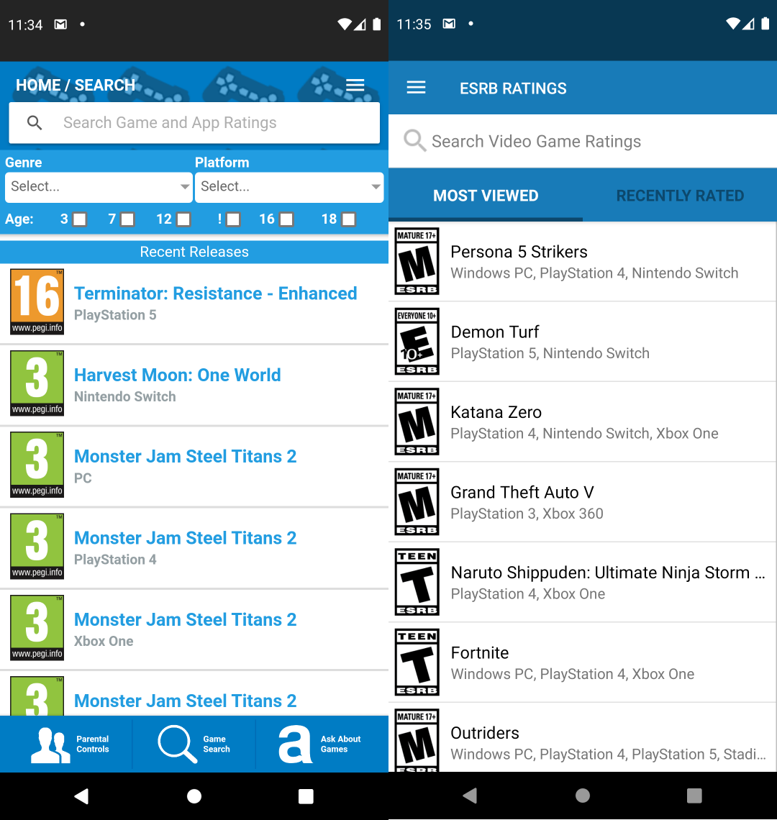
Home Screen
Figure 1: A comparison of the home screens – i.e., the first screen a user sees – of the ratings board apps.
Initially, the two apps look very similar: both open into a list of game titles and their attached ratings. This suggests that both apps adopt a transient posture (Cooper, 2007). It is obvious to anyone with even a casual awareness of games what the list screen is, and the search bar to find a specific title is obviously placed.
Figure 1 provides a valuable point of comparison between the two databases supporting the applications –the PEGI database records the same title multiple times, once for each platform. This results in a confusing user experience and should therefore be avoided when developing the prototype.

Lesson 1: A list of games with a search bar is an effective opening screen because it is a high-affordance design that immediately informs the user of what is expected of them and what they can expect from the app.

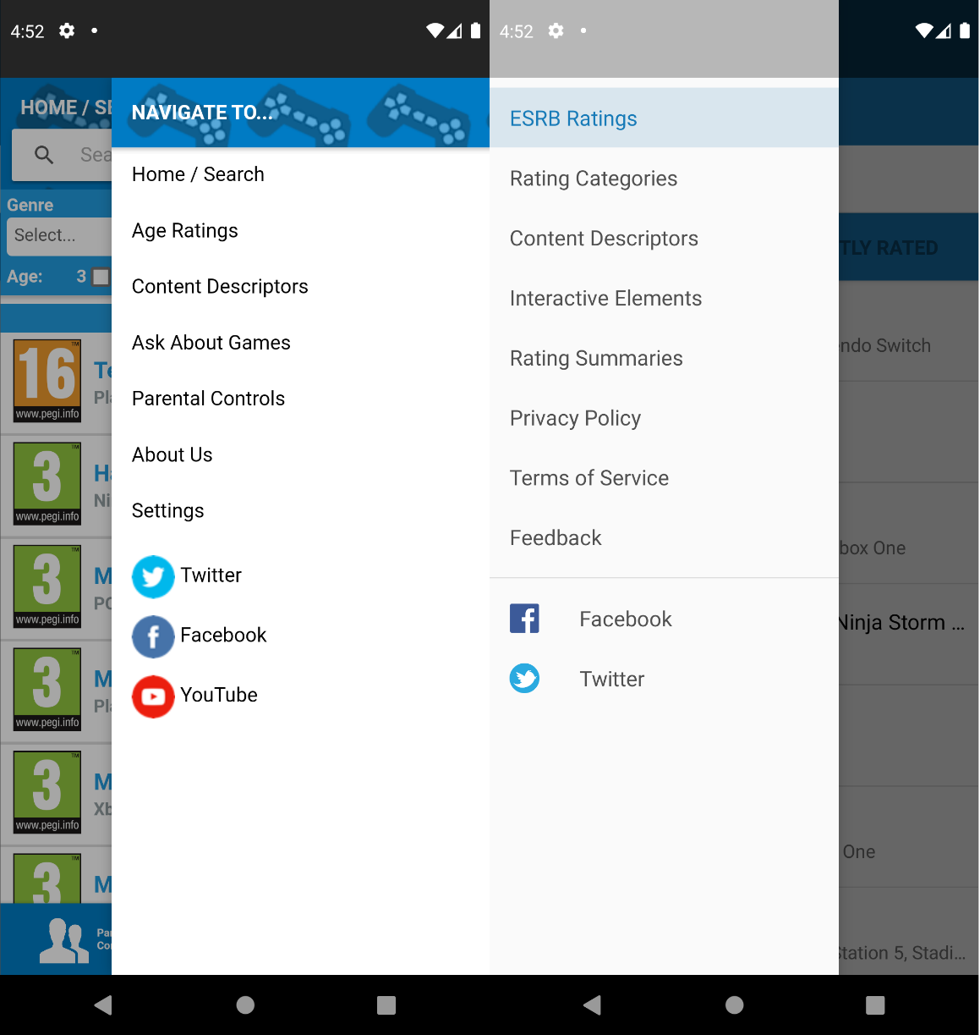
Navigation
Figure 2: A comparison of the navigation menus, also called Burger Menus due to the icon used to represent them.
The burger menu as seen above is a common standard; an efficient means to handle navigation while ensuring unlimited scalability for new features. Where both apps fail is in the naming of the pages one can navigate to from this menu – both feature page titles that do not clearly indicate what is on the page.
The ESRB app uses the title “ESRB Ratings” for the home page even when four other pages – labelled “Rating Categories”, “Content Descriptors”, “Interactive Elements”, and “Rating Summaries” – could be described with the same language. This is confusing to a new user, and the prototype should avoid making the same mistake.
The PEGI app also has a confusing navigational UX – it uses both a burger menu and bottom tabs, but the options presented in the tabs are available through the menu, making the tabs redundant.

Lesson 2: Navigation should be conceptually as simple as possible and clearly labelled to avoid confusing the user.

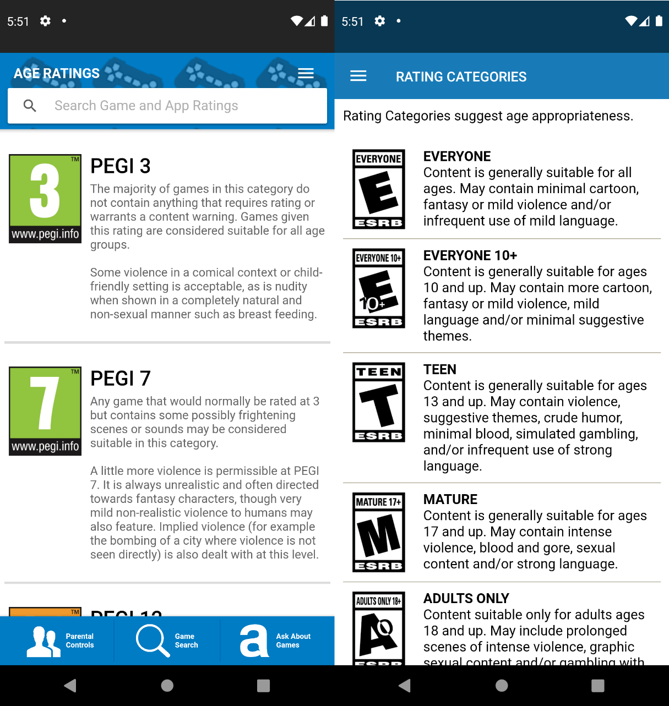
Other Screens
Figure 3: A comparison of the two screens displaying ratings categories.
The relevant screens not covered above in both apps are mostly plain text or text with a few images. While this is an obvious and utilitarian approach, it does invite the question of whether there might be a more engaging or clear way to convey information than simple text. The above image is a representative example – both apps contain additional similar screens dominated by non-interactive text.

Lesson 3: Minimise the use of pure text as much as possible.

METHODOLOGY
This chapter will explain the approaches taken to the project. It will detail both the project management methodology utilised as well as the development methods employed and why.

Project Management
In any project, time management and planning are key. It was therefore necessary to select a project management methodology to manage time and ensure that work was done expediently. Because of the scope of the project, it was important to select a methodology with as little overhead as possible. Kanban (Anderson, 2010) was chosen because it requires only one artefact (Radigan, 2021) – the Kanban board, which can be highly customised to the needs of a given project (Rehkopf, 2021). That meant that a simple board provided the structure of a project management methodology without imposing the same level of overhead that a more complex methodology would.
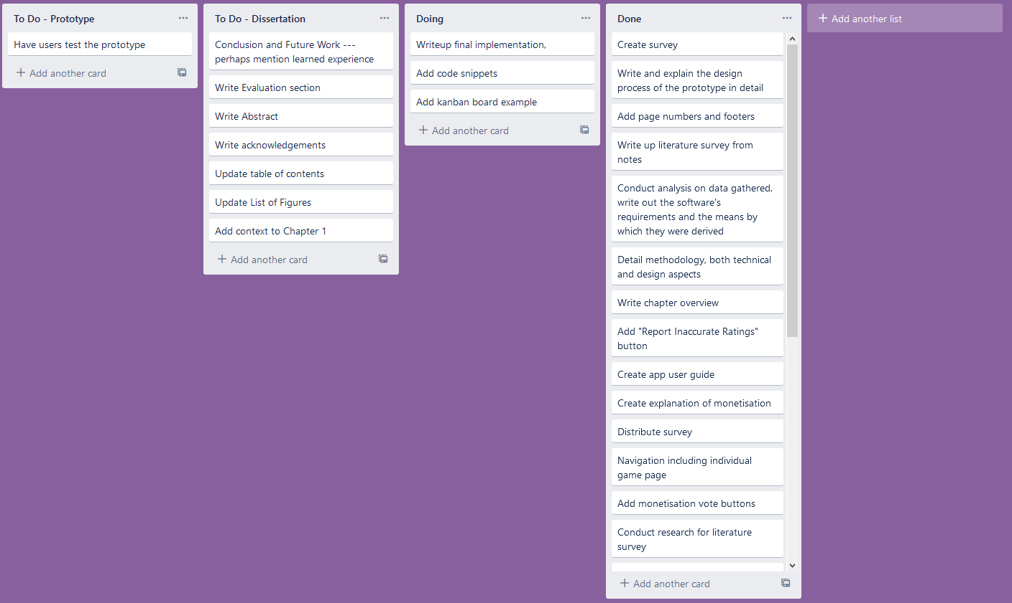
Figure 4: The Kanban board that was used for this project.
The project’s Kanban board was created and hosted using Trello (Atlassian, 2021). Initially, the board was populated with high-level goals that had to be achieved, with more granular tasks added as need arose during the project.

Research and Development
The next step was to ascertain the requirements for the prototype. This was done via a survey distributed via Discord, a gaming-oriented instant messaging and VoIP software (Discord Inc., 2021). This survey provided insight into the thoughts and attitudes of twenty-two individuals that represent a typical hobbyist gamer.

Meanwhile, a development methodology was chosen. While Agile methodologies are currently extremely fashionable (Raunak and Binkley, 2017), the project’s limited timescale led to the decision to use Waterfall (Royce, 1987) because it requires no iteration, and the project’s scope is sufficiently focused that its weaknesses are not evident. Since the project aims to develop a prototype, an iterative process would be excessive.

The first stage was design, focusing on UI and UX design according to established principles and practices (Norman, 2013). Screens were planned and designed based on earlier analysis using FluidUI, a web-based user interface design software (Fluid Software, 2021) because it provided an expedient means to draft screen designs. It was then necessary to devise a categorisation system for the different kinds of additional monetisation employed in games.

Work then began on the implementation process, which started with the selection of the software and tools that would be employed for the development of the prototype and the selection of the games database that the app would employ, which were then used to build the prototype.

Upon completion, the prototype was sent to four volunteer testers. Participants were asked to behave as though the information provided by the app was correct, and evaluate the prototype’s functionality accordingly.

ANALYSIS
This chapter will analyse the results from the survey and use these to derive a specification. It will analyse the most significant findings and the implications thereof - full results in Appendix F.

Survey Results
The survey was conducted to gauge opinions and knowledge on the current state of information regarding additional monetisation in games from hobbyist gamers on the subject and to find individuals who would be open to testing the finished prototype.

The survey was hosted using Google Forms (Google LLC, 2021) because it allowed unlimited respondents and questions for free and as such provided everything that was necessary with minimal investment.

The survey was distributed using the online instant messaging and VoIP service Discord (Discord Incorporated, 2021) and reached a small international audience of 22 with respondents primarily from the UK and the US, with one respondent from New Zealand. Little personal data was collected from the participants, with the survey focusing chiefly on knowledge and opinions regarding additional monetisation in games and the impact it has had on the participants and the people they know.

Player Demographics and Spending
The first section of the survey largely focused on playing and spending habits. This information was used to contextualise later answers and build a more thorough picture of the survey’s participants. Most of those surveyed purchased between 3 and 11 games in a year. None purchased fewer than 3, confirming that those surveyed were highly engaged with gaming as a hobby, and are thus likely more well informed than the average consumer.
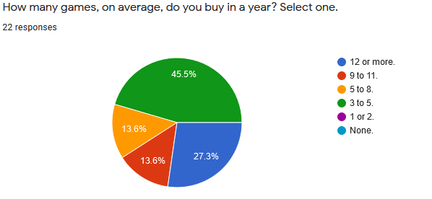
Figure 5: None of the participants said they bought fewer than three games a year on average, demonstrating the level of engagement with gaming as a hobby of those surveyed.

Knowledge of Additional Monetisation
Knowledge of additional monetisation was extremely high. All respondents reported familiarity with all techniques that the survey asked about, though two said they were unsure of the meaning of the term “season pass”. It is quite likely that these responses represent much greater knowledge of the subject than that of the public at large. It is useful, however, that so many of the survey’s participants stated such a high level of understanding in the survey, as part of the survey’s purpose was to source testers for the prototype – testers with knowledge of the subject area can feedback regarding the classification of monetisation techniques used and are therefore highly valuable.

Opinions of the Game Industry and Monetisation Strategies
Next, the survey moved on to recording their opinions of the game industry and additional monetisation strategies which it employs. All participants said that they want to know whether and what kinds of additional monetisation is in a game before they purchase it, yet also felt that customers are not well informed on the monetisation features found in games and that game rating boards do not do enough to label games with such features. This suggests a lackadaisical attitude from the ratings boards, which should not be surprising given that these organisations are often self-regulatory organisations founded by the game industry (ESRB, 2021). Their job is to protect corporations from government scrutiny, and as such they have a vested interest in rating games as vaguely as they can get away with.
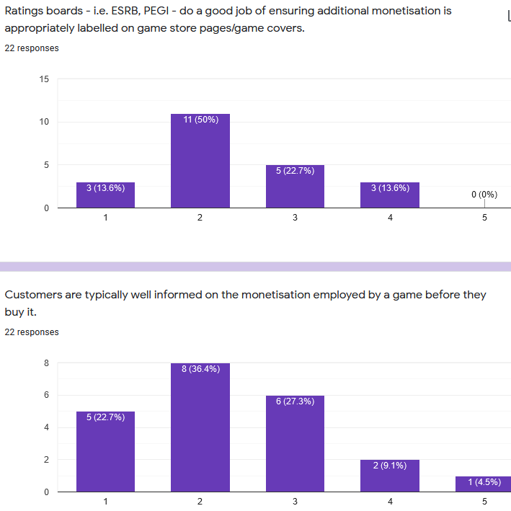
Figure 6: Participants’ general opinions of the state of information in the games industry is low – broadly, those surveyed felt that ratings boards did not do enough and that most consumers are ill-informed on additional monetisation.

In the third section, participants were asked for their personal opinions on certain common monetisation strategies. When asked, 14 of those surveyed said they felt microtransactions generally negatively impact the player experience. Of these, 6 said they believed that they negatively impact all players while the others believed that only those who did not purchase them were negatively affected.

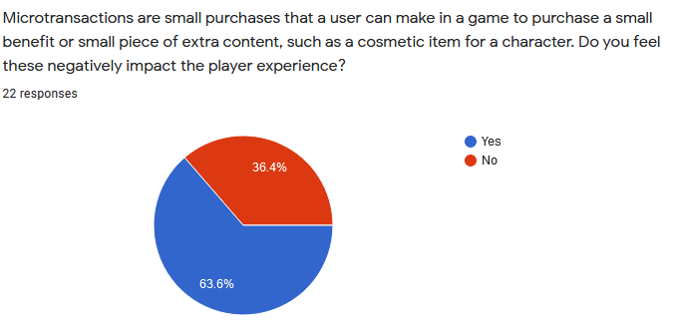
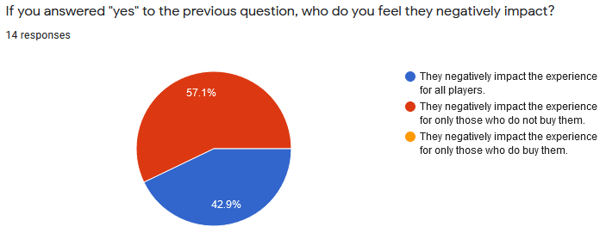
Figure 7: Most participants felt that microtransactions negatively impacted the game experience, but only for those who do not buy them.

When asked, most participants said that microtransactions positively impact the player experience - but only for those who purchase them.
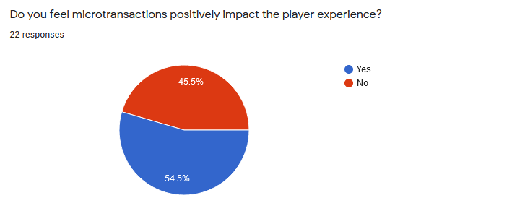
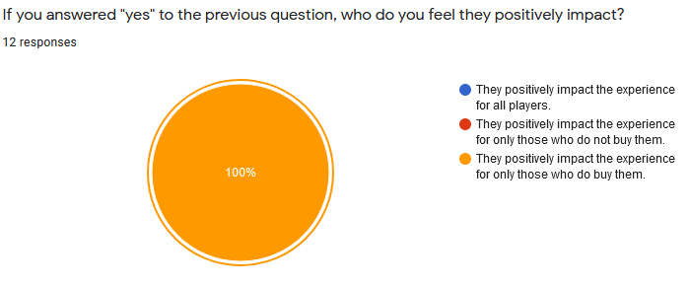
Figure 8: Most participants felt that they improved the game experience, but only for those purchasing them.
At first glance, the idea that an optional purchase – microtransactions – can worsen the experience for everyone seems counter-intuitive. To understand this viewpoint, the broader industry context must be considered: the introduction of microtransactions has caused shifts in game design (Heimo et al., 2018, Petrovskaya & Zendle, 2021). It is now relatively common for publishers to sell solutions for problems that they create, like the ability to purchase a microtransaction to avoid a long period of grinding to earn in-game rewards. Such features are now found in multiplayer games such as Grand Theft Auto: Online (GTA:O) and single-player games like Assassin’s Creed: Odyssey. Both offer microtransactions for in-game benefits for which one must otherwise grind. In GTA:O, for example, players progress through earning in-game money. Take Two – the publisher – and Rockstar – the developer – make such progression extremely time consuming by making in-game items cost a great deal while making in-game rewards comparatively little, thereby artificially increasing the appeal of the microtransactions on offer - called “Shark Cards” -which allow players to exchange real world money for money in GTA:O. This has meant that, in the opinions of many players, the mere presence of microtransactions has incentivised design to encourage spending (Petrovskaya & Zendle, 2021).
When asked specifically about their exposure to loot-boxes, all but one of those surveyed said they had seen them on offer in games they have played. The majority said they felt that loot-boxes purchased with real-world money should be considered gambling by law, and most of them extended that to loot-boxes purchased with in-game currency in cases where in-game currency could be purchased with real money.

Gambling
When asked, 18 of the 22 surveyed said that they felt some games contained features that could be considered real-world gambling. This is interesting because a later question asked whether they had played “a game that contains the ability to exchange real-world money for randomised in-game benefits”, and 20 of the 22 said that they had. This indicates that two of those surveyed did not feel that paying money for a randomised outcome was gambling – psychologists disagree (Drummond & Sauer, 2018).

All respondents said they had heard of people spending excessively on randomised content in games, and 7 confirmed that they knew someone who has had issues in the past with gambling in games. 5 respondents claimed to know someone who must avoid certain games due to the gambling-like content they feature, and 5 respondents admitted to knowing someone who had encountered financial trouble due to overspending on additional game monetisation.

These findings indicate an extremely high level of exposure to gambling-like content in digital games and a significant number of people who have come to harm due to such exposure.

Survey Conclusions
Due to limited sample size, the conclusions that may be drawn from the survey are proportionally limited, but some useful information has been gained that pertains to the group that was surveyed.

From the survey’s results, it is reasonable to draw the following conclusions:

- Highly engaged hobbyist gamers generally want to be informed as to whether a game uses additional monetisation, and if so, which kinds.

- The same group typically knows what a given monetisation technique is and how to identify it.

- Many such individuals know someone who has caused some harm to themselves through gambling in digital games.

- Such individuals are often dissatisfied with the rating systems offered by game industry self-regulation bodies.

These conclusions support this project’s premise – that a tool with which players could identify which games used additional monetisation and how they use it, would be well received. Furthermore, they suggest that crowd-sourcing ratings may be a viable approach if inputs can be sufficiently limited to prevent vandalism and the ratings can be overseen by the publisher of the tool.

Specification
The following is a specification for the prototype which was derived from background study of similar apps and from the findings of the survey.

Scope
Due to budgetary constraints, the focus of the project will be on the development of a front-end prototype since cloud infrastructure has a cost. This means that user generated data cannot be accurately modelled, and the artefact will have to mimic such data using placeholders.

Description
The app will adopt a transient posture (Cooper et al., 2007) – the intended use is that a user opens the app to look up a game or otherwise reference information, and when finished closes the app. It is not intended to hold the user’s attention for a long time, only to tell them what they need to know. It may deliver information on the nature of games ratings and their content, but the focus is on informing the user on the additional monetisation techniques games employ.

User Needs
The app will have to assume zero or minimal knowledge on the part of the user in the subject domain – not all users will be as informed as the survey participants. The app will need to be able to inform the user of additional monetisation techniques, what they are, how they work, and any associated terminology. It will then need to have some way to allow a user to see which techniques a game employs, because no ratings board accurately rates for them. The survey indicates that crowd-sourcing this information, with appropriate input limitations and oversight, may be the best approach. It will additionally accommodate experienced users who are already familiar with the subject domain, and just want to use the app quickly and effectively.

The app is not a parental control app. It is not intended to help parents keep their children away from content they deem objectionable, so a focus will not be placed on the standard content ratings from any ratings board. The app is a tool for those who wish to avoid games with additional monetisation for any reason. These reasons may range from moral or principle-based objection to an outright gambling addiction that means loot-boxes pose a serious risk to a user’s wellbeing. This may include parents who wish to safeguard their children, but no special accommodation will be made for content restriction.

Functional Requirements
The app’s features will be defined according to the MoSCoW method (Clegg and Barker, 1994), a proven method for considering and implementing the features of projects of this scale.

Must Have Features:
The most obvious functional requirement is a page featuring a searchable list of games from a database. Because ratings boards do not rate for additional monetisation techniques, the app will need to have a system for that which does not require extensive manual data entry due to the costs associated with such a process. This means that it will crowd-source monetisation ratings, since no open database of such information exists. Such a system would need to be highly limited in the input users can give, to avoid vandalism of the kind commonly seen on review aggregators (Tomaselli et al., 2020). Finally, the prototype must feature space to offer information regarding additional monetisation techniques – what they are, how they work, and associated terminology. This is to accommodate users with less knowledge of the subject domain, like casual players or concerned parents.

Should Have Features:
There are some things that the prototype should feature that are not critical to its function. The most useful of these would be an option for users to report inaccurate ratings for a given game – even with a limited content rating system as mentioned previously, the potential for vandalism still exists. The prototype should acknowledge this and provide evidence of how a user might report inaccurate ratings for human review. In addition, the app should provide at least the basic age ratings given to a game for the user’s convenience.

Could Have Features:
There are features that are non-essential but could still be useful that can be added if time allows. Most notably, it could increase its utility by offering explanations of the meanings of the various age ratings, as well as to show and explain the various content descriptors that ratings boards apply to games. This would serve to increase user convenience while highlighting the reluctance of these regulatory bodies to appropriately label the monetisation that appears in the games they rate.

Won’t Have Features:
No version of the app will offer reviews or review aggregation. Such a feature would undermine the design goals of the app by distracting from the issues at hand and would open the system to malicious vandalism in the form of review bombing (Tomaselli et al., 2020). Additionally, the prototype will not attempt to accommodate for ratings boards outside of ESRB or PEGI or for titles not rated by those authorities.
A full version could attempt to localise for smaller regulatory bodies, but priority should always be given to PEGI and the ESRB as the two largest regulators. Finally, the prototype will not use any actual first-party cloud-based data storage as cloud resources have a monetary cost which is not viable at this time – it will only mimic any such functionality. Naturally, a full version would need such a backbone infrastructure to function.

Table of Functional Requirements
Designation | Requirement | Priority Rating
FR1 | App prototype features a searchable list of games from a database. | M
FR2 | App prototype features a rating system for additional monetisation that does not require extensive manual data entry. | M
FR3 | The rating system provides a means to crowd-source information while limiting potential for vandalism | M
FR4 | The prototype offers space to provide information to consumers regarding different kinds of additional monetisation techniques. | M
FR5 | Users can report incorrect ratings information for any given game. | S
FR6 | The prototype provides age rating information for the games shown. | S
FR7 | Explanations of the individual age ratings are given. | C
FR8 | Explanations of the various content descriptors are given. | C

Non-functional Requirements
Most crucially, the prototype must feature the top ten most popular games as determined by SteamCharts.com (SteamCharts, 2021). This is a useful way to check that the most relevant games currently on the market – at least in the PC space – can be found and rated using the prototype. Given that, statistically, a user is likely to look up any one of these games, it is worth ensuring that they all function as intended to help ensure the best possible experience with the prototype.

Additionally, the prototype must not feature any wait times more than six seconds long without the presence of a loading indicator – a lengthy waiting period with no indicator may lead a user to believe the application has crashed and cause them to cease testing early, even though nothing is wrong. Ideally, the prototype will feature an intuitive design with strong UX.

Table of Non-functional Requirements
Designation | Requirement
NR1 | Prototype can be used to search for the top ten games as determined by SteamCharts.com as of 31/05/2021:  - Counter-Strike: Global Offensive  - Dota 2  - PLAYERUNKNOWN’S BATTLEGRONDS  - Apex Legends  - Team Fortress 2  - Grand Theft Auto V  - Rust  - ARK: Survival Evolved  - Football Manager 2021  - PAYDAY 2
NR2 | Wait times are no longer than six seconds without loading indicators when tested on a real mobile device.
NR3 | User testers have no major complaints about the UI or UX design.

DESIGN
This chapter will enumerate and explain the design decisions made for each screen. Since all users of the app will be broadly using it for the same purpose, agile methods such as user stories and use-case diagrams were deemed excessive, and a greater focus was instead placed on the user interface and experience.

Categorising Monetisation Strategies
The first step was to distinguish and categorise the different additional monetisation strategies employed by games so that the user voting system could be implemented. Based on the taxonomy put forth by Petrovskaya and Zendle (2021) a categorisation system that is appropriate for the purposes of this app was derived. Using the findings from this research, broad categories were first identified, and from these, individual techniques were isolated so that users of the app could vote on whether that technique features in a particular game. The categories identified were as follows:
Categories | Included Techniques
In-game Advertising | - Advertising for in-game content  - Advertising for related products  - Advertising for unrelated products
Content Access | - DLCs/Expansion Packs  - Premium Subscriptions  - Content Carving  - Season Passes
Additional Microtransactions | - Cosmetic Microtransactions  - Currency Microtransactions  - Gameplay Microtransactions  - Boosters  - Wait-skipping  - Core Features Paywalled

This categorisation is based loosely on the taxonomy referenced above but is modified based on the findings of the survey conducted for the project to be more easily identified by players.

Front-end Designs
Due to the project’s focus on the user, the design work focused on user experience and front-end design. This was done with high-fidelity mock-ups produced using FluidUI (Fluid Software, 2021). These were used in place of the more conventional wireframe-to-graphic design workflow because emphasis for the prototype was functionality – or the appearance thereof – and the strength of the user experience, not aesthetics. Further interface revisions were made during implementation to accommodate the realities of the tools and techniques employed, and the designs herein were based largely on the lessons found in Chapter 2.

Games List Screen
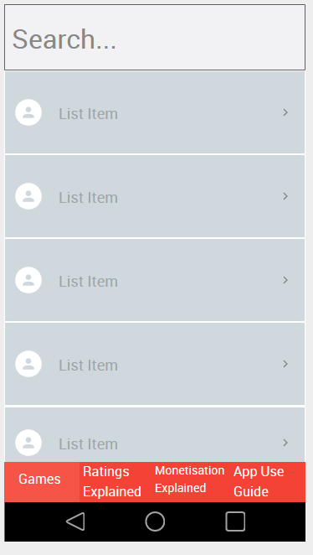
As the most fundamental screen in the app, the Games List screen was chosen as the app’s home screen. This results in a high affordance design (Norman, 2013) which immediately communicates to the user what the app expects them to do; a list below a search bar is a common design paradigm.
Figure 9: The mock-up for the games list screen of the prototype. Simplicity and clarity are key design priorities.
The immediate availability of the search bar plays into the app’s intended transient posture by minimising the friction for a user to reach their goal of viewing a specific game’s information page.

Game Information Screen
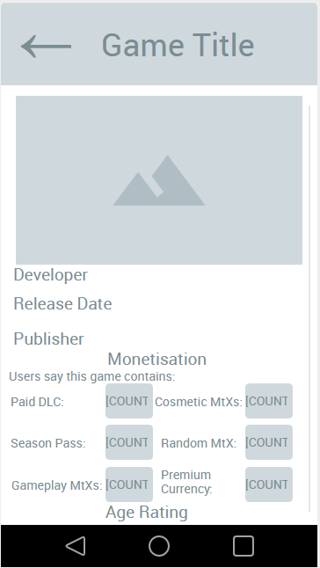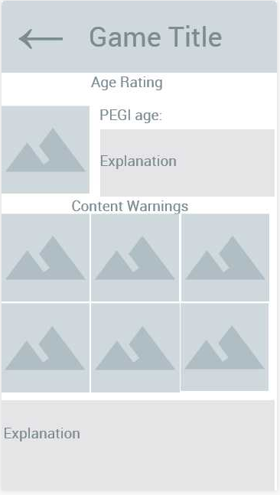
Figure 10: The mock-up for the Game Information Screen, which shows information about the game the user selected from the earlier Games List Screen.
When a user selects a game, they are taken to that game’s screen. This features the game’s cover and title, as well as the developer, publisher, and release date. This is to minimise confusion in the case of games with similar titles and to improve awareness of the role of the publisher in additional monetisation schemes. Initially, the app was designed only to accommodate PEGI ratings, with localisation a low priority.

Below the general information is the Monetisation section, which consists of several labelled buttons. These buttons are vote counters that indicate how many users have said that the game in question uses that technique. A user can tap on the counter to vote for a given technique being used in a game. The inspiration for this design came from the Reactions feature of Discord (Discord Inc. 2021) which is often used to administer informal polls and provides a simple and clean interface. This design is not flawless: it is arguably not obvious that a user may cast their own vote by tapping the relevant counter. This was an intentional trade-off – quick and easy visibility of the number of votes was determined to be a greater priority than an intuitive indication of the user’s ability to vote.

The next section features the age rating assigned to the game along with an explanation of that rating’s meaning. It will feature an image of the rating’s icon and a written explanation. Below that is the Content Descriptors section, which will feature any content descriptors attached to the game in question. The simplest way to handle content descriptor information is to display the icons for any applicable descriptors with text below, but a more elegant solution would be to allow a user to tap on a descriptor’s icon to learn more from a modal pop-up.

Monetisation
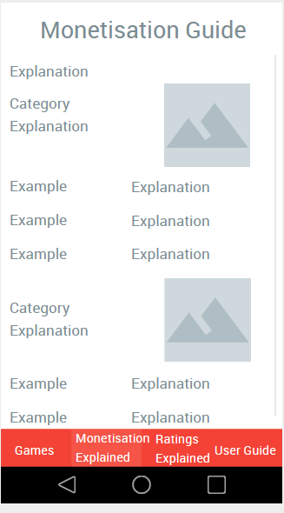
Figure 11: The Monetisation page is designed to efficiently communicate information about different monetisation techniques.
The monetisation page is largely populated by static information, mostly text with some images to serve as icons for the categories. Each “example” is one type of monetisation within a category, as discussed in Section 5.1. By maintaining the categorisation across screens and grouping ideas together and assigning icons to the groups, the screen makes it easier for a user to retain the information.

Ratings Explained
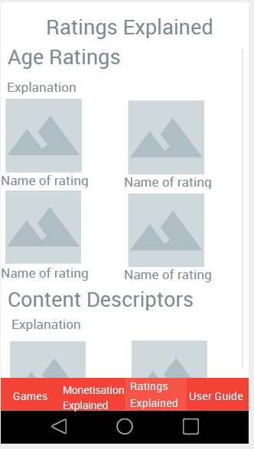
Figure 12: The Ratings Explained page shows the badges given by the ratings board for each rating.
This page will inform the users of the various ratings given to games. In the prototype, only PEGI ratings will be accommodated, but in a final release of the app, a drop-down menu could be used to select which ratings board ratings are shown.

The icons for each age rating or content descriptor can be tapped, which will cause a modal to appear which allows a user to see the details of that rating’s meaning. The image-heavy design was chosen so as not to intimidate or bore users; the text is hidden using modals will contain the image and the meaning of the rating. This would allow information to be more spaced out because a modal occupies the full screen.

User Guide
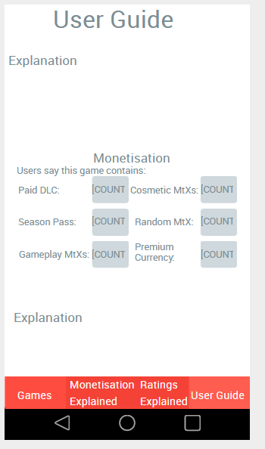
Figure 13: The User Guide page will mostly feature text but will use dummy versions of the interactive features from other screens to demonstrate how they work.
This page of the app will use dummy interactions to demonstrate how the other parts of the app work as well as written explanations for how to use the app. This will include the voting system from the game page as well as the ratings icons from the ratings explanation screen.

The purpose of the screen is to explain to users how to interact with the other screens in the app and what they are for, and so will be simple in layout and design.

IMPLEMENTATION
The goal of this stage was to produce a self-contained fully functional front-end prototype. This eliminates the costs that a fully functioning app would have incurred due to its need for cloud infrastructure while still achieving the project’s aims. This chapter details the decisions and techniques that were used to produce the artefact.

Core Frameworks, Runtime Environment, and Software
The first step was to choose the framework which the app would be built upon. React Native (Facebook, Inc., 2021) was chosen because it is open-source and cross-platform – though due to the budgetary constraints of not owning any Apple devices, the prototype is designed for Android only.

React Native was used alongside Node.js (OpenJS Foundation, 2021), an event-driven back-end JavaScript runtime environment that executes JavaScript outside of a web browser. It is typically used to allow for use of JavaScript in command-line tools and for server scripting, and it was chosen for its support of asynchronous I/O.

Expo (Expo, 2021) is an open-source framework and platform for universal JavaScript apps that builds and signs universal JavaScript apps that use React Native. Used alongside React Native and Node.js, it allows for instantaneous build and testing on both actual and emulated devices and is ideal for quick iteration and development.

Combining React Native, Node.Js, and Expo made it possible to develop a mobile app extremely quickly in a way that is easy to test and set up. Android Studio (Google and JetBrains, 2021) was used only for the Android Virtual Device (AVD), an Android emulator that was used for most of the app’s testing.

React Navigation
The app’s navigational schema was set up first. This was done using the React Navigation framework (React Navigation, 2021). Navigation was done first due to project structure – the screens of the app are loaded after the React Navigation framework, so it made sense to develop the screens after it was implemented. The colour was changed from the red in the screen designs to blue because blue is widely regarded as a neutral colour for UI design – it lacks the semantic connotations of red, yellow, and green, which are often used in warning systems.
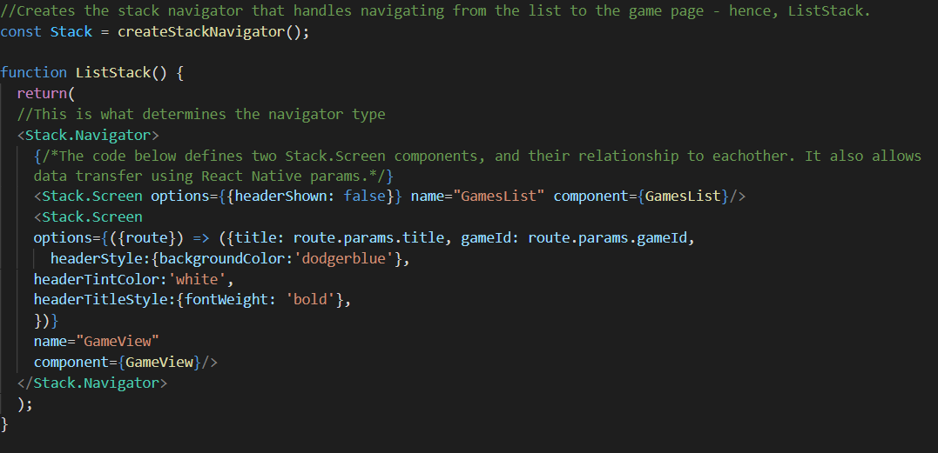
Figure 14: Code for the Stack navigator. The Tab navigator functions similarly but is more complex.
In the React Navigation framework, app navigation is handled using “navigators”, specialised components that dictate which screen the app renders and when. For most purposes, the navigators that come shipped with the framework are more than sufficient when developing an app as they represent widely used navigational standards that are seen in a wide array of apps. This prototype used two: the primary navigator used was a ‘BottomTab Navigator’, which uses tabs across the bottom of the screen to allow a user to select the screen they want in a non-linear fashion; a secondary navigator was then nested inside the first – a ‘Stack Navigator’, named for its similarity to a stack of cards – that would allow the Games List page to lead to the Game Screen.

Database Selection
The first step in the development of the Games List screen was to select a games database from which to pull data using an API, as several games databases are available for use by the public. Three such databases were considered for this project: the Internet Game Database (IGDB) (IGDB, 2021), RAWG (RAWG, 2021), and the Giant Bomb Database (Giant Bomb, 2021). The following compares these three and justifies the selection of the Giant Bomb database.

Internet Game Database
The first choice was IGDB, which is managed and used by Twitch – the dominant player in online game streaming (Twitch Interactive, 2021) – meaning that it would be the most reliable of the three and likely have the highest level of data integrity. It also offered unlimited requests from free users. Unfortunately, some time into the development process it became clear that IGDB’s API documentation was too difficult to understand and work with, partly because API requests relied on POST instead of GET, which complicated request structure significantly. This appeared to be one of many security measures employed by the API that ultimately made it difficult for a single inexperienced developer to use.
I would still recommend IGDB’s use if this app were to be developed and deployed commercially for the same reasons that made it unfeasible to use for the prototype – high security, high integrity, and high availability, ensured by the fact it is in Twitch’s best interest for that to be so.

RAWG Database
RAWG is an independent database with rich metadata and a large dataset. The data is extensive, and the API is much more user friendly than that of IGDB, with clearer documentation and a simpler query structure. The only reason that the RAWG API was not chosen for the prototype is that it has a hard cap on the number of API requests that can be made by an application per month at the free service tier. At the time of this decision, inexperience working with API requests and getting data from an external source meant that a hard cap on the number of requests seemed unwise due to the possibility of a defective function making too many requests and mistakenly wasting the finite number of requests allocated.
This is no longer a concern due to experience gained working on the project, and if the prototype’s development were to continue into a full-fledged app it would be switched to using RAWG as it has greater data integrity and richer metadata than Giant Bomb’s database.

Giant Bomb Database
The third option was the database of games media website Giant Bomb. They have a large publicly accessible games database, and their API has the simplest query structure of all three databases investigated. Additionally, while requests are rate-limited to a certain number per hour, there is no finite cap. These two factors make it an ideal database for learning how to use data from an API, and while the database itself is imperfect, it is easily sufficient for the purposes of the prototype.

These factors led to it being selected for the prototype’s database, but if the prototype were to develop into a full-fledged app, it would not use the Giant Bomb database. The API’s search function is limited, and the database is community run, leading to issues with data integrity – typographical errors and missing data are not uncommon.

Data Retrieval
Retrieval of data was handled using REST API requests over HTTP. These requests were tested using Postman (Postman Inc, 2021), a graphical HTTP client that is used to develop APIs. Once tested and functional, the calls were implemented in the prototype as functions that rely on Axios (Axios, 2021), an open-source asynchronous HTTP client for Node.js that can be implemented in a React Native app as a library and used to make HTTP requests. The data was retrieved in JSON format for ease of decomposition and used wherever it was needed in the app.
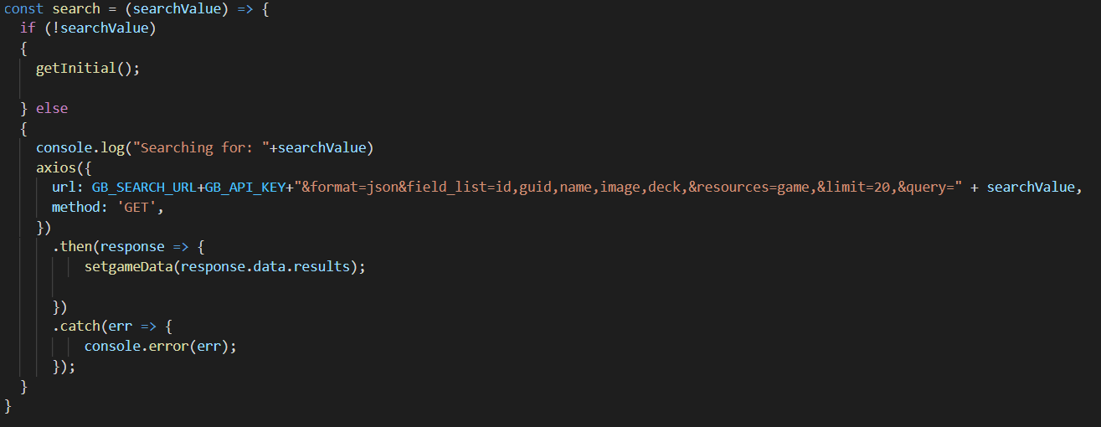
Figure 15: Code for the “search” Axios request to allow a user to search for a game.

Games List Screen
Next, a component was required to render each item that the API call returned. This was done using a custom component called “RowCard” which displays the game’s cover art and its title.

Figure 16: The RowCard component in use.
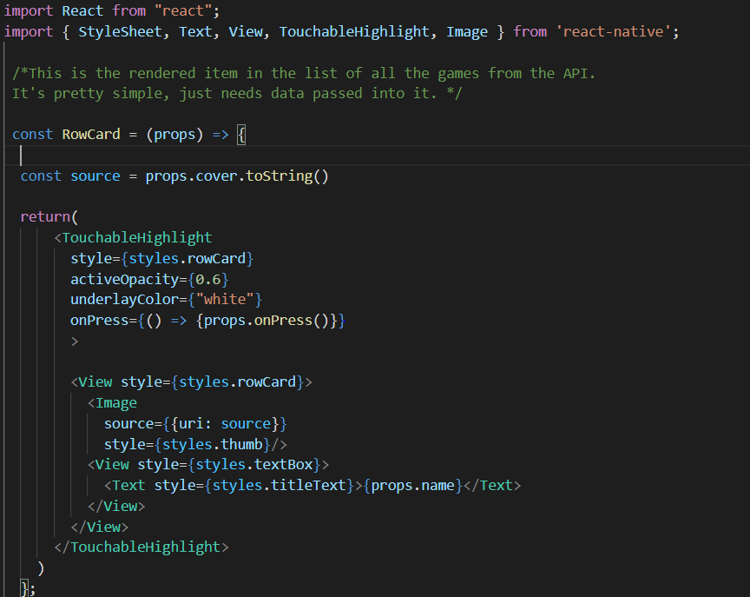
Figure 17: The RowCard component code. Stylesheet not pictured.
The RowCard takes the information from the API call and displays the cover art and title for each game the call returns. When the RowCard was complete, it was made to render inside a ScrollView so that the app showed a scrolling list of them.
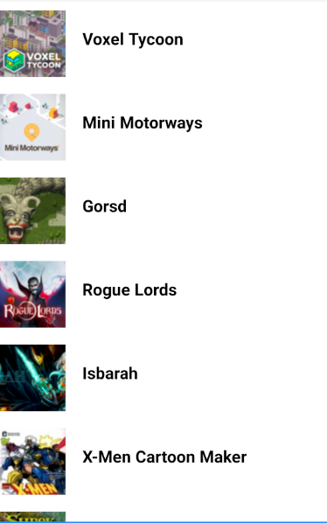
Figure 18: The list of games returned when the API call is made, featuring several instances of the RowCard component.
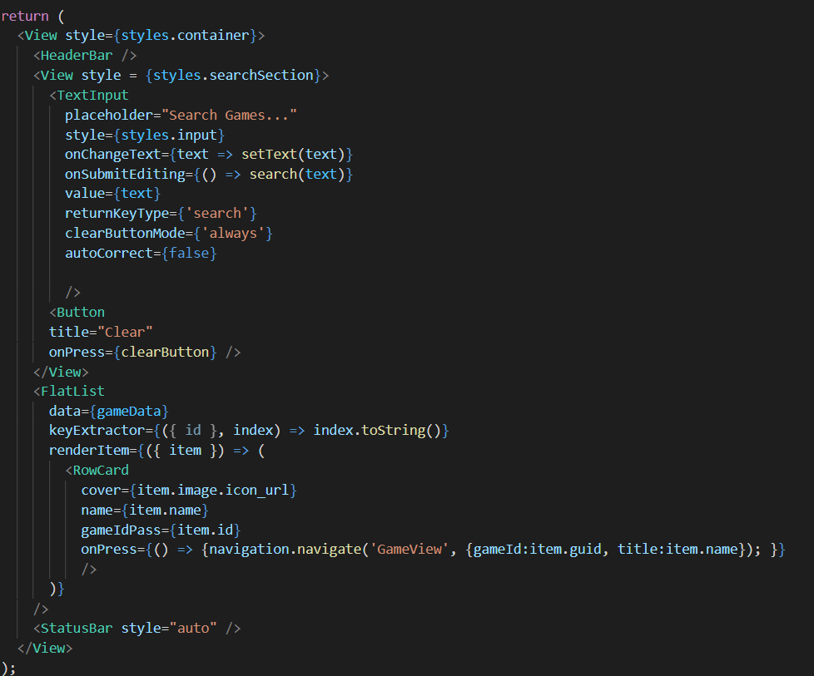
Figure 19: The code for the GamesList screen. Data retrieval and storage functions not pictured.

The GamesList now shows a scrolling list of games. By default, it shows the most recently added titles to the Giant Bomb database. This was left as-is because most users will need to search for a specific title anyway and a more useful initial sort - such as popularity - was not available with the Giant Bomb API.

Next, a search bar was necessary. Search bars in React Native work by using a TextInput component from React Native with a few event listeners attached so that it knows when to trigger a search call to the API. Searching whenever a new character is entered is possible, but would be inefficient because it would make too many API requests too quickly and would slow down the host device.
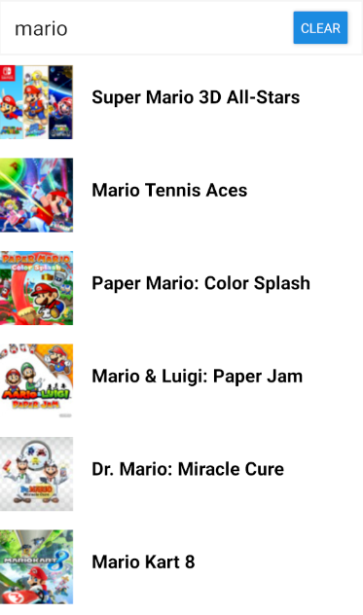
Figure 20: The search bar in use on the Games List screen.
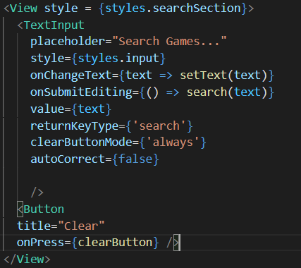
Figure 21: The search bar code.

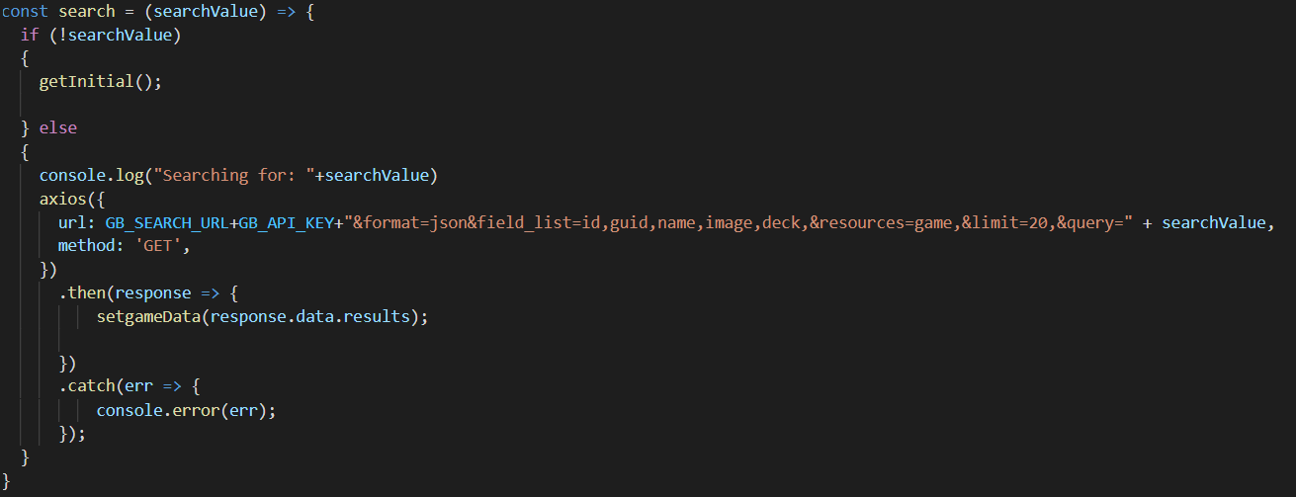
Figure 22: Search function code.
The search bar was implemented and functional, but there was no way to conveniently clear the search bar to start a new search. To remedy this, a clear button was needed. However, if the button only cleared the search bar, the app would search for an empty string. This would naturally return nothing, and the app would appear to have broken. It was necessary to return the default search when the search bar was empty, and this was done with a single if-statement in the search function that triggered the getInitial() function that retrieved the initial games list. With that in place, a button was added to the search bar which, when tapped, would clear the search bar. The search bar would search for nothing, thereby triggering the if-statement mentioned above, causing the list to display the initial games list.
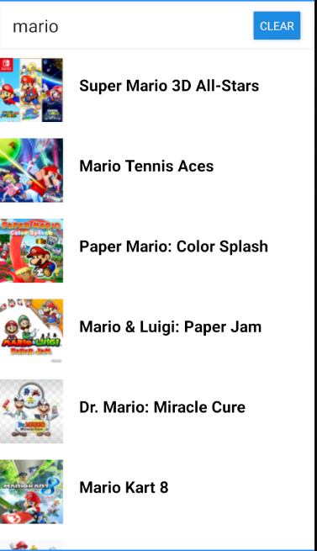
Figure 23: The full finished GamesList page, featuring the Clear button in the Search bar; a functional and clear design.

Game Information Screen
When a game is chosen from the list, the user is taken to the screen for that game.
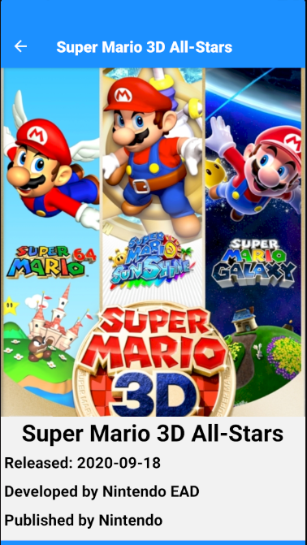
Figure 24: A sample of the Game Screen when first opened showing the full cover art, title, release date, publisher, and developer.
When the game screen is first opened, it shows some useful information for general information purposes. This is useful in the context of additional monetisation because certain publishers tend to use the same monetisation schemes across multiple games – or at least gain a reputation for using additional monetisation in excess. Scrolling down reveals a brief description of the game as well as its monetisation information.
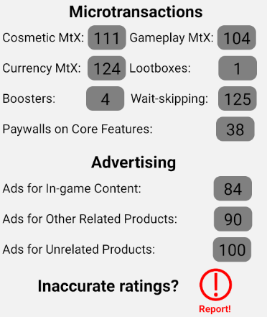
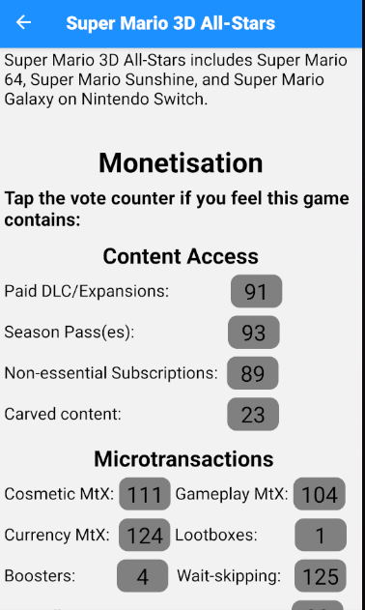
Figure 25: The monetisation section visible below the game’s description.

The monetisation section shown is based on the categorisation developed in Chapter 5. Each of the counters can be tapped to increase the vote. The numbers indicate the number of users that have voted to say that the game in question has that monetisation technique. When the user casts their vote, the counter turns blue and increases by one.
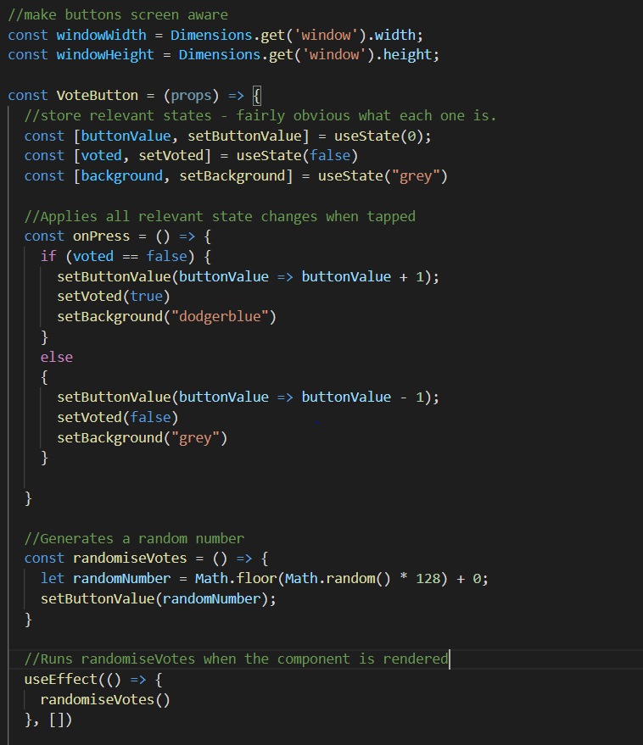
Figure 26: The code for the VoteButton’s functionality.
The counters shown here are a custom component, the VoteButton. The VoteButton in the prototype will randomly generate a number between 0 and 128 and use that as the number of votes. This was done because the alternative is a full database to store the relevant votes for each game, which would take a great deal of time and would not improve the prototype in a meaningful way – random generation of values serves to demonstrate the concept just as well.
Below the vote counters is a report button. In a full version of the app, this button would send a message to the operator of the software informing them that the game’s monetisation votes need to be reviewed manually. How a hypothetical operator would deal with that information is beyond the scope of this project.
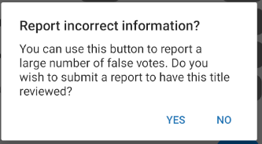
Figure 27: When tapped, the Report button shows this Alert to the user. Tapping ‘no’ closes the alert, tapping ‘yes’ causes another alert to appear telling the user their report was submitted.
In the original design, there was to be a separate section of the game’s information page that would detail the ratings for a particular game. Unfortunately, the information that is offered by the publicly available databases is not detailed enough to permit such information. All three databases only store the age ratings given to a game with no content advisories. In Giant Bomb’s case, which ratings it stores are inconsistent - some games lack rating data at all, others will be rated only for one or two ratings boards despite having been rated by others. As a result, the prototype can only display age ratings – and even the age ratings it does show are limited to those that are recorded in the database.

Figure 28: The prototype’s current Game Rating section, constrained by the limitations of the database.

Other Screens
The original design of the prototype called for three additional screens which could be navigated to using the tabs at the bottom of the screen. Unfortunately, the databases that were available for the prototype to use did not store detailed ratings information, so the Ratings Information screen from the original design had to be cut. As a result, only two additional screens are shown in the prototype – the Monetisation Explanation screen and the User Guide.
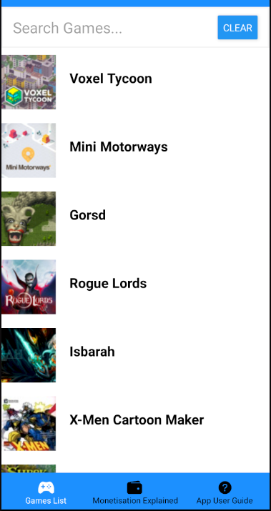
Figure 29: The Games List with the current navigation tabs shown at the bottom.
The other two screens are for the purpose of user information, and so would take the form of largely static pages of text and images, with some minor interaction to demonstrate functions elsewhere in the app or collapse and expand views. As a result, it was deemed unnecessary to fully implement them for the prototype. These screens would be little more than interactive mock-ups, and since the designs in Chapter 5 are high-fidelity, implementing these mock-ups for the prototype did not seem like a worthwhile time investment.

EVALUATION
Evaluation is of vital importance to any project. This chapter will critically evaluate the project’s outcomes by using the opinions of volunteer testers that will be given access to the prototype alongside a reflective comparison of the project’s results versus its stated objectives and requirements.

User Testing Design
The first step was to enlist the help of volunteers. Some participants in the earlier survey consented to being contacted for testing, and since the testing focused on usability, potential users of the software were the most sensible choice of testers. The most efficient way to have the app tested was to allow testers to access, test, and give feedback on the app in their own time asynchronously.

This meant that code needed to be hosted online for the testers to access. Expo hosts projects for testing for free that can be viewed through their mobile app. This is useful as it minimises friction on all sides – the developer can publish the project using a single terminal command, and a tester can access it by downloading a small app from the Play Store and following a QR code.

With the app available for distribution, the next step was to design the form which testers used to offer feedback. The prototype was tested by prospective users, which means that the two relevant objectives are Objectives 4 & 5; users are not being shown the designs, and so Objective 3 does not apply. Questions will therefore be focused on whether the prototype is fit for purpose and free of bugs, as well as each tester’s subjective assessment of the potential utility of the prototype for its intended purpose.

The form distributed to the testers was made and distributed using Google Forms. It was divided into sections as follows: the first section focused on the prototype’s fitness for purpose and how well it communicates information. The second focused on bugs and was brief; it asked testers whether they encountered any and what they were, as well as the tester’s opinion of their severity. The third section focused on the user experience and the design of the app itself, asking subjective questions on the look and feel of the prototype. Finally, the fourth section asked users their opinion of the prototype’s potential as a full product.

To on-board the testers, an invitation was sent out first that told the testers what was expected of them and when the testing phase ended. An information pack was then prepared that included instructions and information on what to expect from the testing process. Careful consideration was taken when creating this pack to avoid influencing the opinions of the testers in any way. The invitation and information pack were distributed via email, using the addresses that survey participants gave when they consented to be invited to test the prototype. The pack included instructions for installing the Expo Go app, the necessary QR code that it needs to access the prototype, a link to the feedback form, a deadline, and limited information about the prototype and its purpose.

Evaluation Execution
Of the 11 survey respondents from Chapter 4 who agreed to be contacted for testing, 4 signed up to test the prototype. These four were allowed time to test the prototype and were anonymous.

Tester Findings
In the interest of brevity, this section will make only broad observations in most cases, analysing in depth only where interesting. The full responses can be found in Appendix I.

Fitness for Purpose
Section 1 of the testing form focused on the prototype’s suitability for its intended use. Questions focused on the clarity of information shown and the prototype’s ease of use. All testers said that finding a specific game was extremely easy and that information shown was either clear or extremely clear. Two testers said that the meaning of the numbers shown on a game’s screen – the vote counters – were of moderate clarity, but none said that they were at all unclear. All testers felt that a full version of the prototype would do a good job of communicating information about additional monetisation in games.

Bugs
Three of the four testers reported no bugs. One low-severity bug was found. According to the tester, scrolling from a point occupied by any of the buttons would cause the button to trigger and in one case would prevent scrolling. The bug was only partially reproduced – when trying to reproduce the bug, the score buttons did not trigger when scrolling, but the Report button did.

User Experience
Overall reception of the User Experience was positive with no negative opinions recorded. One tester reported only a 3/5 for user-friendliness and that the middle navigation tab was cut off, suggesting that more testing is necessary before the prototype could be made into a full app to ensure compatibility.

Potential
The overall perception of the prototype’s potential was very positive. All testers felt that the final app would be useful to them personally. Only one tester felt that the prototype did not include all the features they would want, suggesting that the experience could be improved by the addition of a “Dark Mode” theme and a text scaler, to improve accessibility. This is an extremely valuable suggestion, but time does not allow for such a feature to be added to the prototype.

Researcher Evaluation
Having examined the opinions of third-party testers, it was possible to evaluate the prototype from the perspective of the project’s stated objectives and requirements.

Objectives
Objective 1 focused on identifying the impact additional monetisation has on the players exposed to them. Objective 2 was similar but focused on the findings of academics vis-à-vis the impact and ethics of additional monetisation. Through the literature survey conducted in Chapter 2 and the first-hand research shown in Chapter 4, these objectives have been achieved. The first-hand survey in Chapter 4 examines the impact on players, accomplishing Objective 1, while the literature survey examines the findings of academics, and as such satisfies Objective 2.

Objective 3 focused on the design, requiring that it be capable of fully informing a person with no knowledge of additional monetisation techniques. Given the feedback from the testers and the similarity to the prototype to the designs, this objective has been accomplished.

Objective 4 is to build a prototype that communicates the kinds of additional monetisation used by different games while Objective 5 concerns ensuring the prototype is of sufficient quality so as not to misrepresent the experience of using the final product. While Objective 4 has been accomplished, Objective 5 is more complex.

To determine whether Objective 5 has been accomplished, it is necessary to examine the criteria specified earlier in the project.

Objective 5 had three criteria:

- The prototype has undergone informal testing by the developer, and any bugs discovered are fixed.

- The prototype has undergone user testing and been found to have a strong user experience which clearly communicates the necessary information.

- The prototype has undergone user testing and any severe bugs found by testers have been fixed.

Informal testing was a constant presence during the prototype’s development, and issues found were fixed as and when they appeared, satisfying the first criterion. The second criterion has been satisfied, as indicated by the User Experience section of the testing form. Finally, while the testers did find a bug, the tester that found the issue rated its severity at 2/5 on a scale from “extremely trivial” to “made the prototype unusable”, which means it is a trivial issue. As such, the third criterion can be considered satisfied and thus Objective 5 accomplished.

Requirements
The artefact itself merits evaluation based on its fulfilment of the requirements set for it in Chapter 4. The following is a table indicating the status of each functional and non-functional requirement. For the requirements tables, see Sections 4.3 & 4.4.
Designation | Requirement | Priority Rating (Where Applicable) | Completion Status
FR1 | App prototype features a searchable list of games from a database. | M | Complete.
FR2 | App prototype features a rating system for additional monetisation that does not require extensive manual data entry. | M | Complete.
FR3 | The rating system provides a means to crowd-source information while limiting potential for vandalism | M | Complete.
FR4 | The prototype offers space to provide information to consumers regarding different kinds of additional monetisation techniques. | M | Complete.
FR5 | Users can report incorrect ratings information for any given game. | S | Complete.
FR6 | The prototype provides age rating information for the games shown. | S | Complete.
FR7 | Explanations of the individual age ratings are given. | C | Incomplete.
FR8 | Explanations of the various content descriptors are given. | C | Incomplete.
NR1 | Prototype can be used to search for the top ten games as determined by SteamCharts.com as of 31/05/2021:  - Counter-Strike: Global Offensive  - Dota 2  - PLAYERUNKNOWN’S BATTLEGRONDS  - Apex Legends  - Team Fortress 2  - Grand Theft Auto V  - Rust  - ARK: Survival Evolved  - Football Manager 2021  PAYDAY 2 | N/A | Complete.
NR2 | Wait times are no longer than five seconds without loading indicators when tested on a real mobile device. | N/A | Complete.
NR3 | User testers have no major complaints about the UI or UX design. | N/A | Complete.

Based on the number of requirements met and the priority level of unmet requirements, the prototype can be reasonably judged to have been successfully built.

CONCLUSION & FUTURE WORK
This project aimed to engineer a solution to the problem of improving the ethics of additional monetisation in the digital games industry without relying on a legislative solution. As such, research was conducted – see Chapter 2 - into the field of games monetisation and its associated ethical concerns and studies. Based on the research, a prototype for a public information app was created. This prototype proved that the ethics of monetisation in the games industry could be improved by increasing transparency and better equipping consumers to protect themselves from exploitative monetisation practices as a stop-gap solution while the law catches up to technology and regulates such practices.

From reviewing literature in the field, it is clear that ultimately the solution to the unethical behaviour of game publishing corporations is going to be a legislative one – corporate entities seldom adjust their behaviour to something less profitable without legal pressure – as scholars in the field (Drummond and Sauer, 2018) recommend. It is apparent from this project’s findings that a stop-gap solution that allows vulnerable consumers to protect themselves in the meantime would be highly valuable and in the interest of the public good.

While the small sample sizes of the research conducted – both the survey and tests on the prototype had fewer respondents than might have been preferable – limit the generalisability of the project’s findings somewhat, the research does clearly demonstrate that at least some people would appreciate and use an app which improved transparency in the game industry, like the prototype developed for this project. The project was limited by its lack of resources to a significant degree – no iPhones available precluded testing the app on iOS, for example, and a lack of time meant that some features were not included, and no back-end designs were produced. Even so, this project has been an innovation in its field – no technical solution for the issue of exploitative monetisation has yet been published. It is my hope that either myself or someone else will build upon the work done in this project and produce a worthy final product to help consumers protect themselves from exploitation.

The methodologies – see Chapter 3 - employed by this project both in a broad project management sense and a developmental sense, have clearly yielded results. As anticipated, the Kanban (Anderson, 2010) project management methodology allowed for appropriate time management and task tracking with minimal overhead due to its singular and simple artefact while the non-iterative development approach ultimately paid off, having resulted in a well-received final product.

The prototype produced by this project was highly successful – it fulfilled all of the non-functional requirements as well as all of the most important functional ones. Only functional requirements with merely tangential relation to the prototype’s core goals were left incomplete, namely those requirements relating to ratings board rating information, FR7 & FR8. It was well-received by the volunteers who tested it, all of whom said they would use an app that was like the prototype shown to them. None of the testers had any major complaints, though some valuable suggestions were given.

The prototype developed as part of this project is not yet ready for use by the general public. For it to become useful, there is some work that must be done. First, the placeholder text that is shown in various areas of the prototype will need to be replaced with actual informational content that informs users about the use of the app and about game monetisation. As mentioned in Section 6.3, it would be wise for the app to transition to a new database, either RAWG (RAWG, 2021) or IGDB (Twitch Interactive, 2021) depending on the scale of the development to be undertaken. The main work that is necessary currently, however, is the development and hosting of a back-end infrastructure capable of storing user votes and moderating the game pages in case of abuse. Without such infrastructure, any released version of this app is useless. With all that completed, the core functionality of the app illustrated by the prototype made for this project would be ready for public use.

Some database of game content descriptors could be developed for a more comprehensive set of game rating information – as no public data for that is available – and this would improve the app’s functionality even further. One of the testers recommended text scaling and dark mode to improve accessibility. These are two extremely valuable suggestions that would have to be included in a successful final app release, along with multilingual localisation and multiplatform compatibility. Finally, the app could be expanded to rate for accessibility issues in games – a subject worthy of its own dissertation, truly – by allowing users to rate for accessibility features in much the same way they would rate for monetisation schemes.

In closing, this project has found that consumers are currently being exploited by game publishers that rely on predatory monetisation schemes to make startling amounts of money at the expense – financial and emotional – of the consumer. These predatory strategies rely on uninformed or vulnerable consumers, and it supposes that by informing the game-buying public of these schemes it is possible to help them protect themselves and increase pressure on the games industry to behave more ethically. This project has successfully demonstrated a means by which consumers might be informed of the ways game publishers exploit them and therefore a means by which consumers might be empowered to protect themselves from predatory monetisation, and while this information app is not yet finished, it has served as a useful proof of concept and viability study. This project has found that gamers want to be informed about monetisation so they can make informed purchases, and the prototype this project has created demonstrates a way in which they could inform themselves and avoid being exploited by corporate interests.

Word count (main body of the report): 10,862 words, not including headings, tables, captions, or citations.

REFERENCES
Anderson, D.J., 2010. Kanban: Successful Evolutionary Change for Your Technology Business [online]. Illustrated Edition. Blue Hole Press.

Atlassian Corporation, 2021. Trello. Version unknown [browser-based web application]. New York City: Atlassian Corporation.

Alha, K., Koskinen, E., Paavilainen, J., Hamari, J., and Kinnunen, J., 2014. Free-to-Play Games: Professionals’ Perspective. Proceedings of DiGRA Nordic 2014.

Axios, 2021. Axios. Version 0.21.1 [HTTP client for node.js]. Open Source.

Bynum, T.W., 2000. A Very Short History of Computer Ethics. American Philosophical Association’s Newsletter on Philosophy and Computing [online]. Summer 2000. Available from: http://www.southernct.edu/organizations/rccs/resources/research/introduction/bynum_shrt_hist.html
[12/05/2021]

Cooper, A., Reimann, R., Cronin, D., 2007. About Face 3: The Essentials of Interaction Design [online]. Second Edition. New Jersey: Wiley.

Cooper, D., 2020. 6 Year Old Spends $16,000 on Microtransactions Using Mom's Credit Card. GameRant [online]. 16th December 2020. Available from: https://gamerant.com/6-year-old-spends-16k-microtransactions-moms-credit-card-sonic-forces-ios-apple/ [30/05/2021]

Clegg, D., and Barker, R., 1994. CASE Method Fast-track: A RAD Approach [online]. Boston, MA: Addison-Wesley Publishing Co.

Discord Incorporated, 2021. Discord. Stable 74432 [application for MS Windows]. San Francisco: Discord Incorporated.

Drummond, A., and Sauer, J.D., 2018. Video game loot boxes are psychologically akin to gambling. Nature Human Behaviour [online], 2, pp. 530–532

Entertainment Software Ratings Board, ESRB, 2021. Our History [online]. New York City: ESRB. Available from: https://www.esrb.org/history/ [18/05/2021]

Entertainment Software Ratings Board, 2021. Video Game Ratings by ESRB. Version 6.0.11 [mobile app]. New York City: ESRB.

Evers, E., Van de Ven, N., and Weeda, D., 2015. The hidden cost of microtransactions: Buying in-game advantages in online games decreases a player’s status. International Journal of Internet Science [online], 10(1), pp. 20-36.

Expo, 2021. Expo SDK. 41.0.0 [SDK & framework]. Open Source
Facebook, Inc., 2021. React Native. Version 0.64.0 [mobile app framework]. California: Facebook, Inc.

Fluid Software, 2021. Fluid UI. Version unknown [browser-based web application]. Dublin: Fluid Software.

Fristedt, T., and Lo, N., 2019. In-game transactions in Free-to-play games: Player motivation to purchase in-game content [online]. Dissertation, Uppsala Universitet. Available from: http://urn.kb.se/resolve?urn=urn:nbn:se:uu:diva-387646 [12/05/2021]

GiantBomb, 2021. GiantBomb Database [public online database]. San Francisco, California: Giant Bomb. Available from: https://www.giantbomb.com/api/ [25/05/2021]

Google LLC, 2021. Google Forms. Version unknown [browser-based web application]. California: Google LLC.

Google LLC and JetBrains s.r.o, 2021. Android Studio. 4.1.1 [IDE and SDK]. California: Google LLC.

Heimo, O.I., Harviainen, J.T., Kimppa, K.K., & Mäkilä, T., 2018. Virtual to Virtuous Money: A Virtue Ethics Perspective on Video Game Business Logic. J Bus Ethics [online], 153, pp. 95–103.

Kimppa, K.K., Heimo, O.I., & Harviainen, J.T., 2016. First dose is always freemium. SIGCAS Comput. Soc. 45, pp. 132-137.

King, D.L. and Delfabbro, P.H., 2018. Predatory monetization schemes in video games (e.g. ‘loot boxes’) and internet gaming disorder. Addiction [online], 113 (11) pp. 1967-1969.

Kleinman, Z., 2019. 'My son spent £3,160 in one game'. BBC News [online]. 15th July 2019. Available from: https://www.bbc.co.uk/news/technology-48925623 [30/05/2021]

McCormick, M., 2012. Waterfall vs. Agile methodology. Washington DC:McCormick PCS

Moor, J.H., 1999. Just consequentialism and computing. Ethics and Information Technology [online], 1, pp. 61-65.

Norman, D., 2013. The design of everyday things: Revised and expanded edition. Basic Books, 2013.

OpenJS Founation, 2021. Node.js. Version 16.2.0 [runtime environment]. California: The OpenJS Foundation.

Paavilainen, J., Hamari, J., Stenros, J., Kinnunen, J., 2013. Social Network Games: Players’ Perspectives. Simulation & Gaming [online], 44(6), pp. 794-820.

PEGI s.a., 2021. The PEGI organisation [online]. Brusells, PEGI s.a. Available from: https://pegi.info/page/pegi-organisation [18/05/2021]

PEGI s.a., 2021. PEGI Ratings. Version 1.1.3 [mobile app]. Brussels: PEGI.

Petrovskaya, E. and Zendle, D., 2020. The Battle Pass: a Mixed-Methods Investigation into a Growing Type of Video Game Monetisation [online]. Available from: osf.io/vnmeq

Petrovskaya, E. and Zendle, D., 2021. Predatory monetisation? A categorisation of unfair, misleading, and aggressive monetisation techniques in digital games from the perspective of players [online]. Available from: psyarxiv.com/cdwhq.

Postman Inc., 2021. Postman. Version unknown [API development platform]. San Francisco, California: Postman Inc.

Radigan, D., 2021. Kanban – A brief introduction [online]. Atlassian Corporation. Available from: https://www.atlassian.com/agile/kanban [17/05/2021]

Raunak, M.S., and Binkley, D., 2017. Agile and other trends in software engineering [online]. 2017 IEEE 28th Annual Software Technology Conference (STC), 25/09/2017 - 28/09/2017 Gaithersburg, MD, USA. Published by IEEE. Pp. 1-7. Available from: https://ieeexplore.ieee.org/stamp/stamp.jsp?tp=&arnumber=8234457 [17/05/2021]

RAWG, 2021. RAWG.io [public online database]. Vilnius, Lithuania: RAWG. Available from: https://rawg.io/ [25/05/2015]

React Navigation, 2021. React Navigation. Version 5 [framework]. Open Source.

Rehkopf, M., 2021. What is a Kanban Board? [online]. Atlassian Corporation. Available from: https://www.atlassian.com/agile/kanban/boards [17/05/2021]

Royce, W.W., 1987. Managing the development of large software systems: concepts and techniques [online]. In Proceedings of the 9th international conference on Software Engineering. The 9th international conference on Software Engineering, March 1987. Washington, DC, USA: IEEE Computer Society Press. pp. 328-338. Available from: https://blog.jbrains.ca/assets/articles/royce1970.pdf [17/05/2021]

Søraker, J.H., 2016. Gaming the gamer? – The ethics of exploiting psychological research in video games. Journal of Information, Communication and Ethics in Society [online], 14 (2), pp. 106-123.

Tomaselli, V., Cantone, G.G., Mazzeo, V., 2020. Complex Features in Review Bombing [online]. In: DSSR Book of Abstracts, Antonucci, L., Kostiuk, Y., eds. 3rd International Conference on Data Science & Social Research. Bari, 10-11th December 2020. Bari: University of Bari Aldo Moro. Available from: https://www.uniba.it/ateneo/editoria-stampa-e-media/linea-editoriale/fuori-collana/BoA_DSSR.pdf [01/06/2021]

Thubron, R., 2017. 11-year-old accidentally spends almost $7,500 on microtransactions using Dad's credit card. TechSpot [online]. April 4th 2017. Available from: https://www.techspot.com/news/68791-11-year-old-accidentally-spends-almost-7500-microtransactions.html [30/05/2021]

Twitch Interactive, 2021. IGDB [public online database]. San Francisco, California: Twitch Interactive. Available from: https://www.igdb.com/ [25/05/2021]

Twitch Interactive, 2021. Twitch.tv [online]. Twitch Interactive. Available from: https://twitch.tv [25//05/2021]

Van Berlo, K., and Liblik, K.C., 2016. The business of micro transactions: What is the players’ motivation for purchasing virtual items? [online]. Thesis (MBA). Jönköping University. Available from: http://www.diva-portal.org/smash/get/diva2:937793/fulltext01.pdf [26/05/2021]

Williams, M., 2017. The Harsh History Of Gaming Microtransactions: From Horse Armor to Loot Boxes. USgamer [online]. 11th October 2017. Accessible from: https://www.usgamer.net/articles/the-history-of-gaming-microtransactions-from-horse-armor-to-loot-boxes [12/05/2021]

Zendle, D., Meyer, R., Ballou, N., 2020. The changing face of desktop video game monetisation: An exploration of exposure to loot boxes, pay to win, and cosmetic microtransactions in the most-played Steam games of 2010-2019. PLoS ONE [online], 15(5), e0232780.

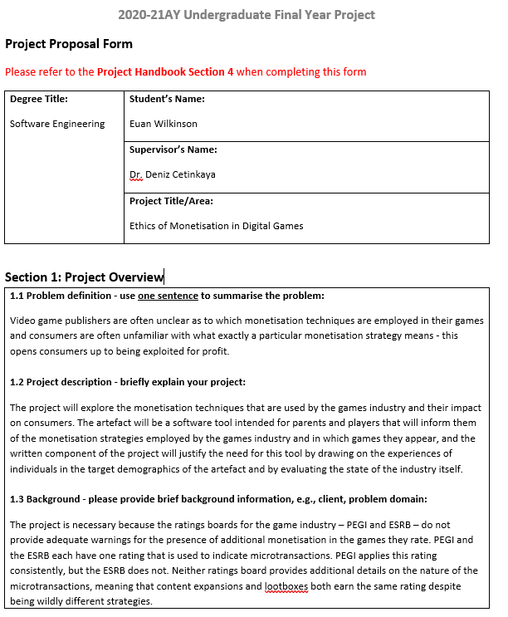
APPENDIX A – PROPOSAL AND ORIGINAL PLAN
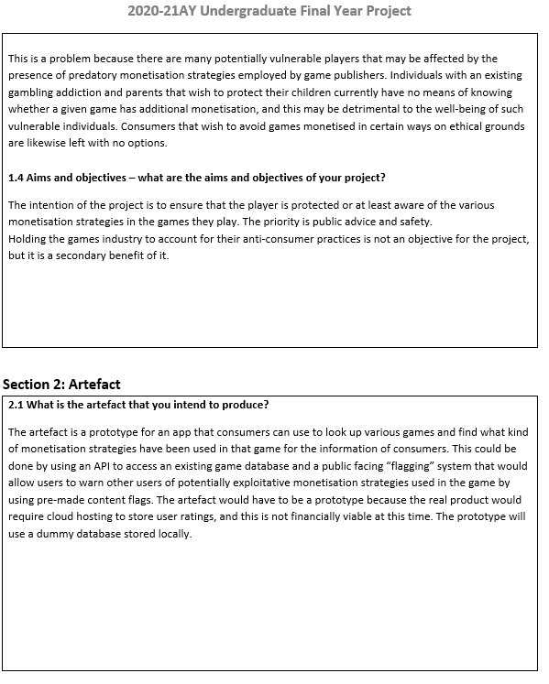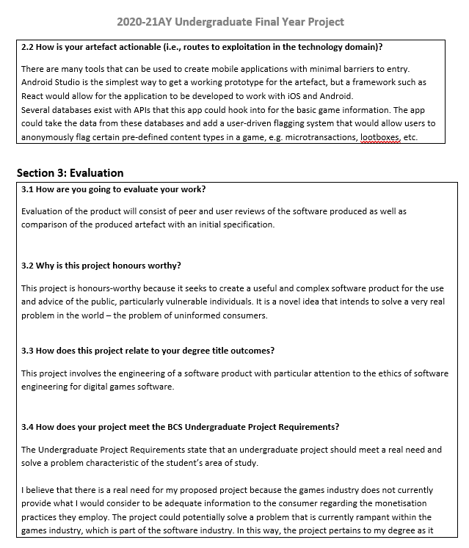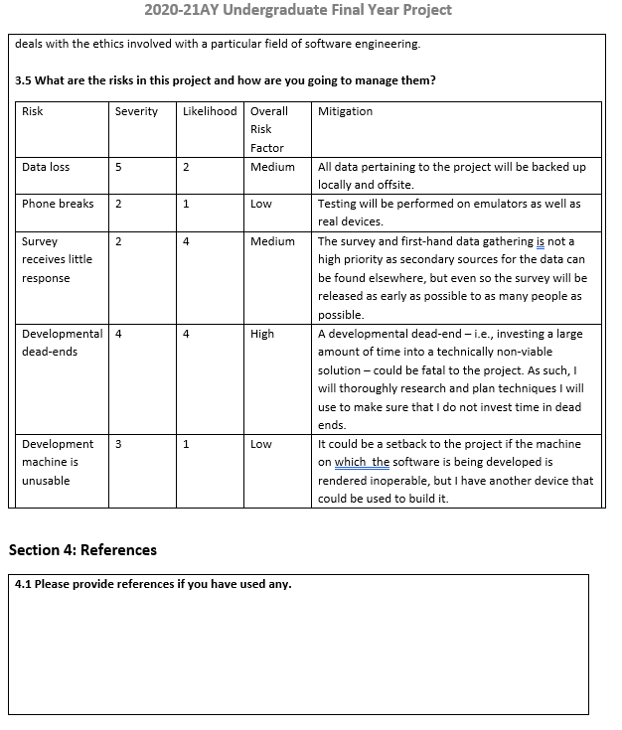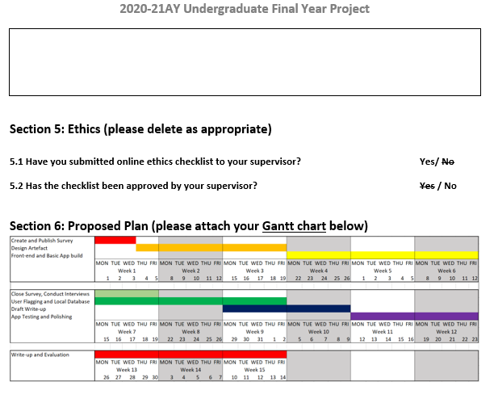

APPENDIX B – RESEARCH ETHICS CHECKLIST

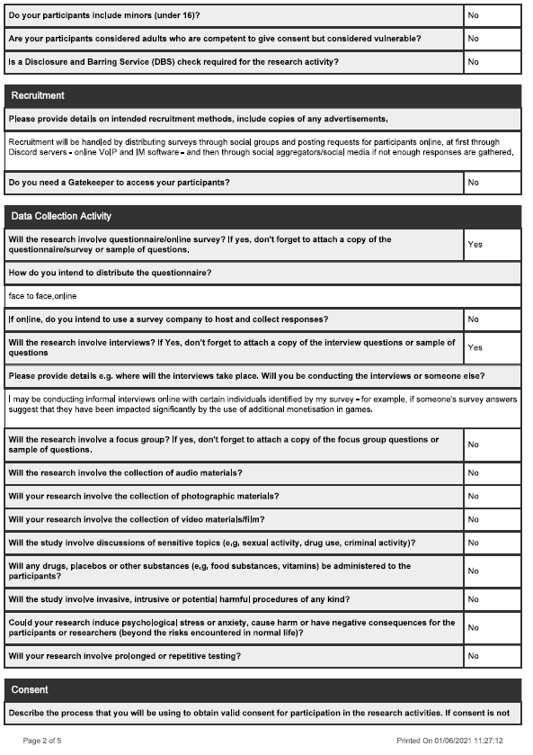
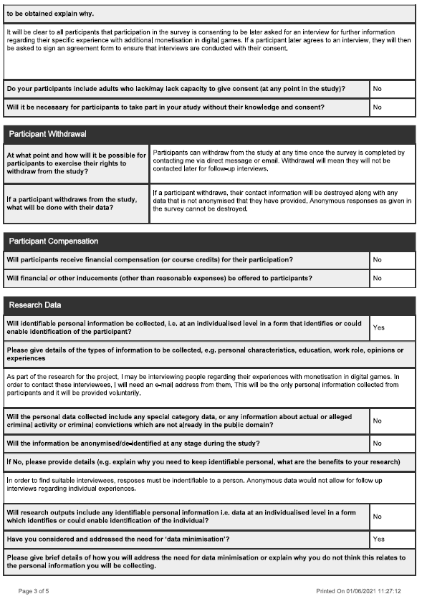

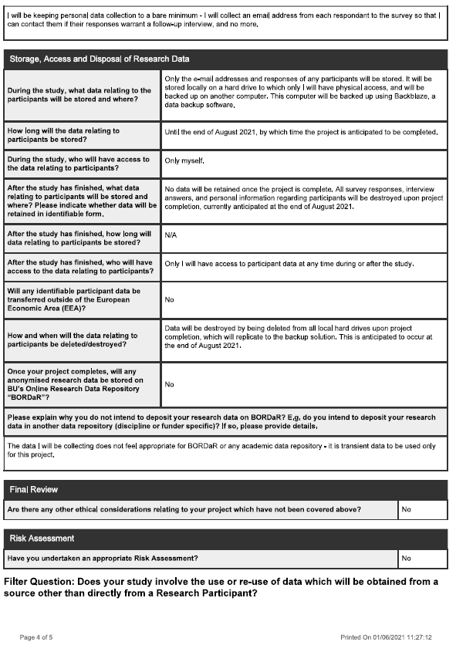



APPENDIX C – INTERIM PROGRESS REPORT
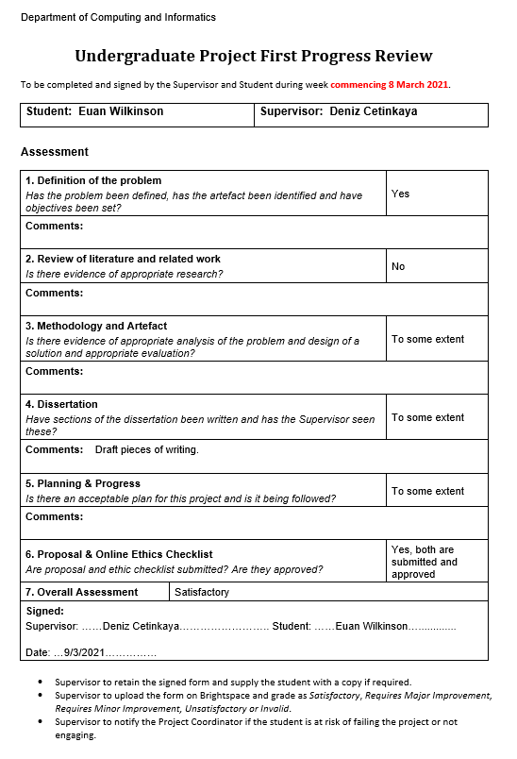

APPENDIX D – DEFINITIONS AND TERMS
Specialised terms will be defined here for clarity either due to non-standard usage or obscurity.

Additional Monetisation: In this dissertation, additional monetisation refers to any kind of monetisation for a game beyond its cost of entry, which may be in the form of purchase or subscription. This term is also used for monetisation in free games, where the monetary cost of entry is nothing, because of the similarity in the techniques employed in both cases.

MMO: MMO stands for Massively Multiplayer Online and originates from MMORPGs – Massively Multiplayer Online Roleplaying Games. MMO has since been taken from the MMORPG label and applied more generally to any game that requires a continuous internet connection and has large numbers of unaffiliated players playing together in a shared game world. Examples of MMOs include browser based MMOs and social spaces such as the now defunct Club Penguin, MMOFPS games such as Destiny, MMORPGs such as World of Warcraft, and dozens of other similar titles.

DLC: DLC stands for Downloadable Content and is a label applied to an additional bundle of content for a game that can be purchased and downloaded. DLC is an evolution of the Expansion Pack, a bundle of content purchased physically for a game a player already owns.

Microtransaction: A microtransaction is a small purchase – typically under $5 – that a player makes in-game. This can be for anything from additional ammunition or lives in a game, to boosters for in-game currency or XP, to cosmetic items and mechanical advantages.

Loot-box: A loot-box is a virtual item purchased via microtransaction whose output is defined by random chance. Loot-boxes might contain anything that a standard microtransaction could, but the actual outcome is not known prior to ‘opening’ the box.

Review Bombing: Review bombing is an internet phenomenon in which users organise to fill a piece of media’s reviews on review aggregation websites such as Rotten Tomatoes or Metacritic with negative reviews which may or may not be spurious. It is often used as a form of protest.

To grind, the grind, grinding: In the context of games, grinding is the act of performing a particular task or set of tasks repeatedly to earn an in-game reward. This reward might be character progression or in-game resources. “The grind” is a term used to describe a period of grinding.

APPENDIX E – RATINGS BOARD RATINGS
Ratings boards tend to rate a game primarily according to the age group for which it is appropriate, then secondarily according to the content found within the games. For the reference of the reader, the ratings given by ESRB (Entertainment Software Ratings Board, 2021) and PEGI (PEGI s.a., 2021) – the foremost two ratings boards – are provided below, both age ratings and content descriptors. The information herein is taken directly from ESRB and PEGI’s respective websites and represented graphically.

ESRB Rating Categories
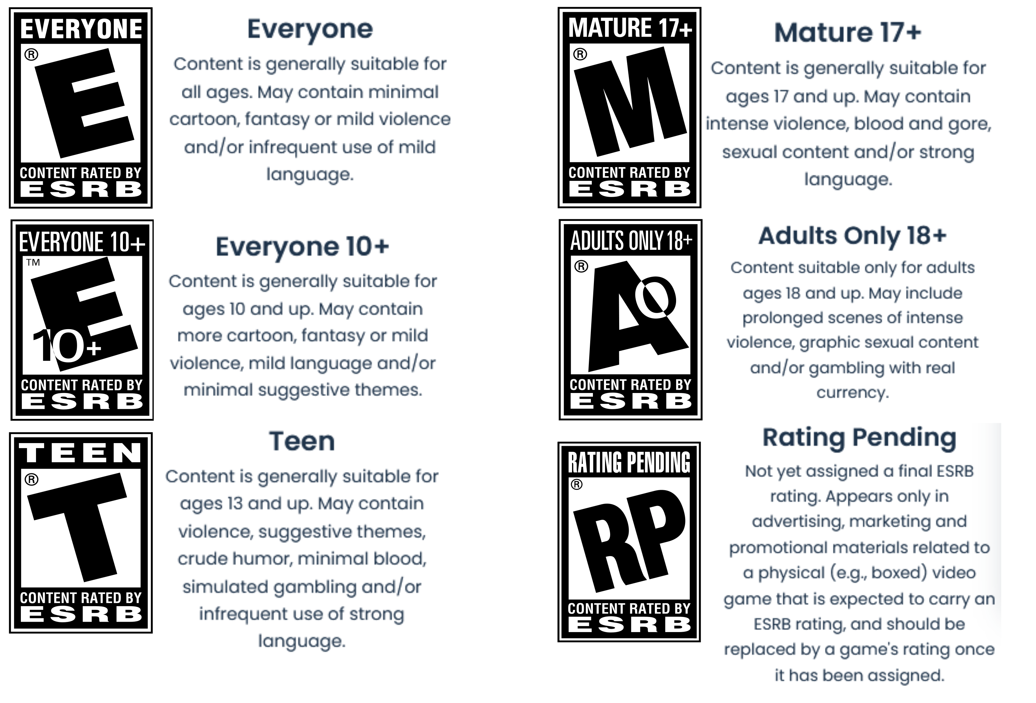
The ESRB does not have icons for content descriptors like PEGI, instead relaying the details in a text box beside the overall age rating.

PEGI Age Ratings
These ratings have been taken directly from PEGI’s website.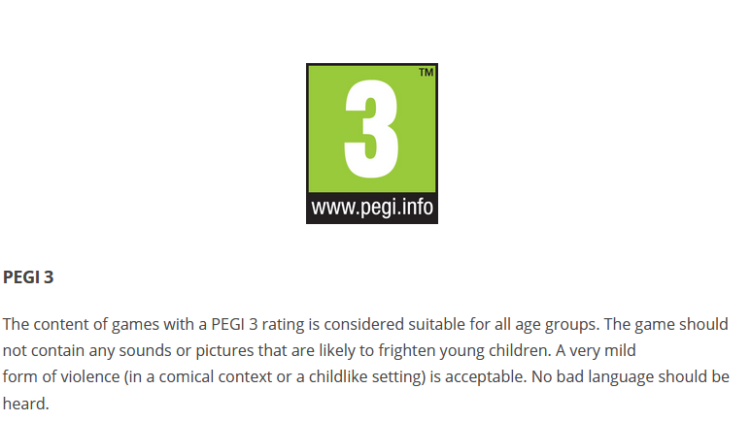



Content Descriptors
PEGI also provides graphical representations for its content descriptors. These can be found on the reverse of a game’s box next to the age rating.
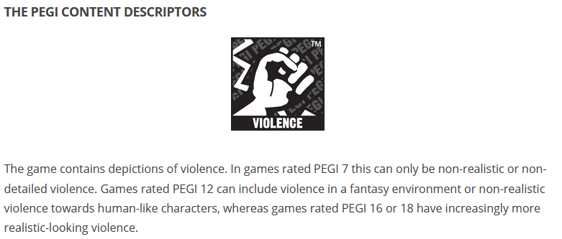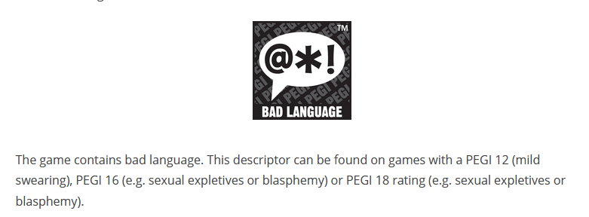
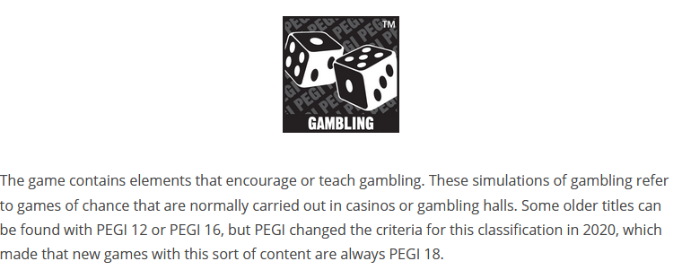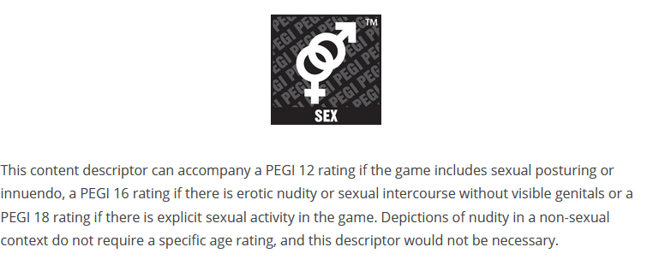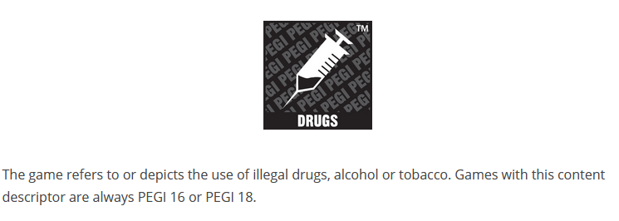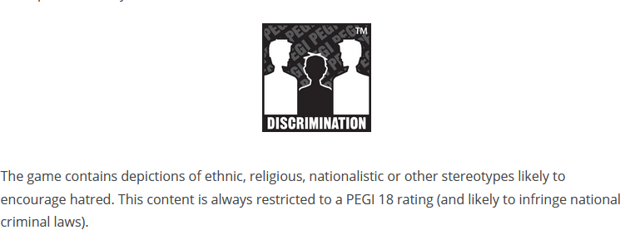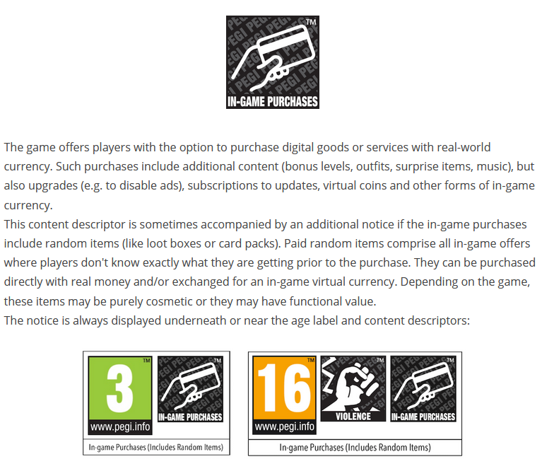

APPENDIX F – SURVEY QUESTIONS AND RESULTS
This appendix will show the questions given in the user survey distributed to the volunteer participants. Some questions have been omitted as they were requests for elaboration that received no responses.
Q1
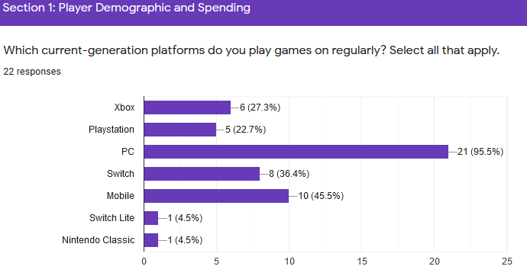
Q2
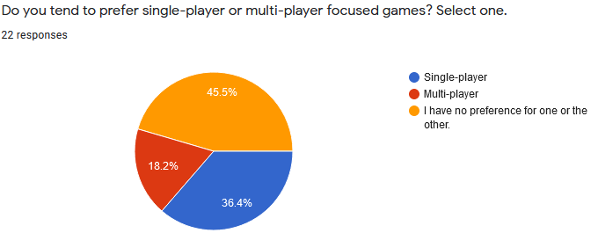

Q3
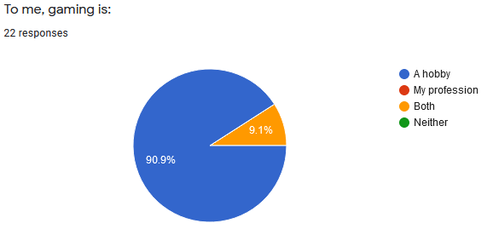
Q4
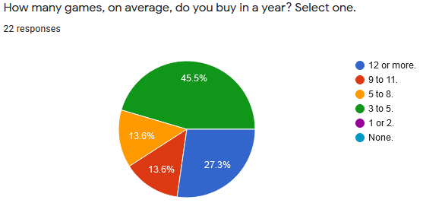

Q5
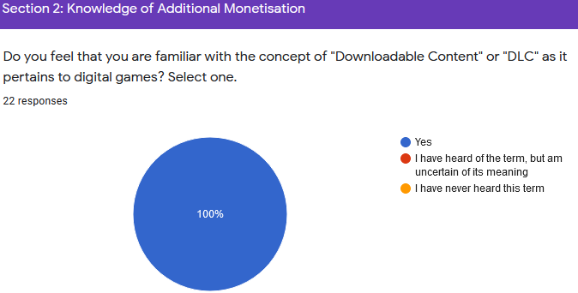
Q6
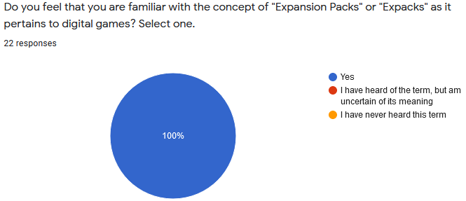
Q7
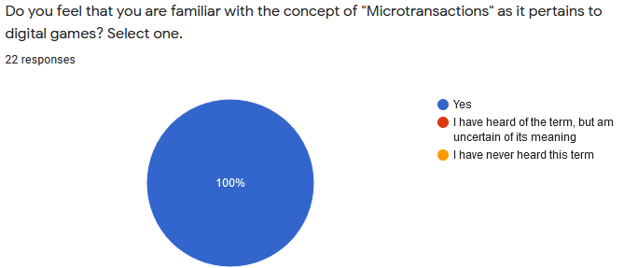

Q8
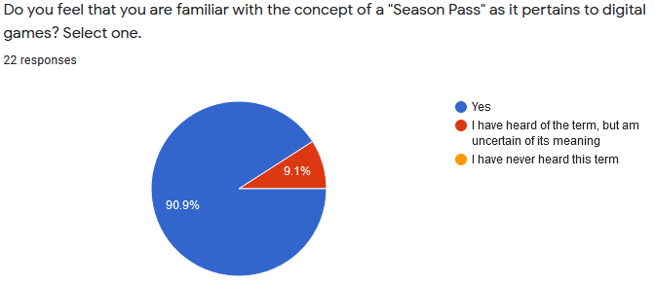
Q9
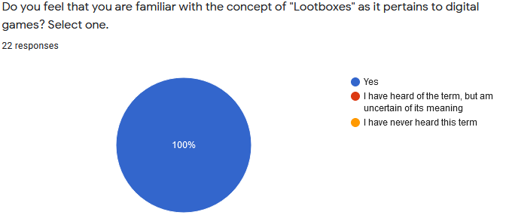

Q10
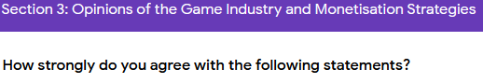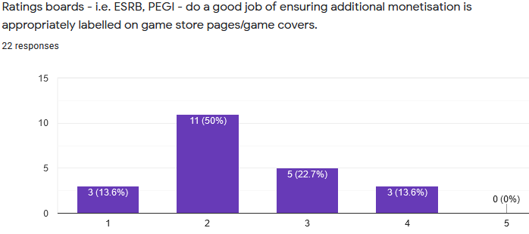
Q11
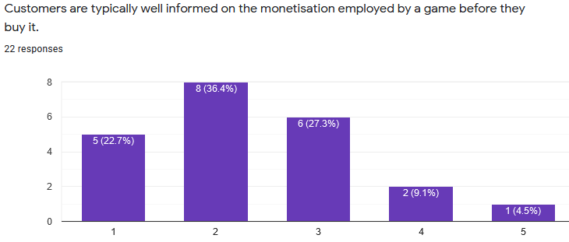

Q12
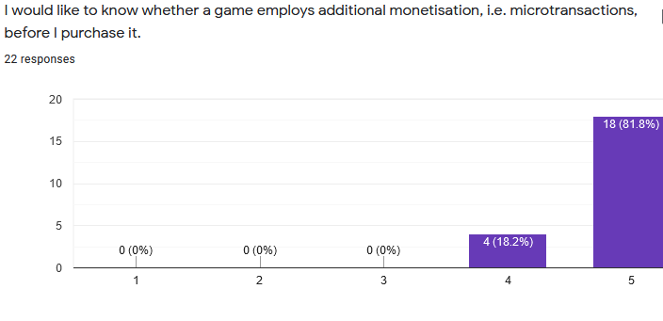
Q13
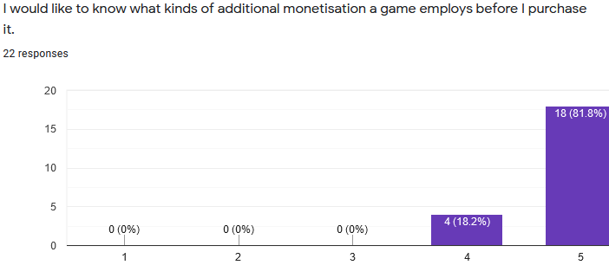
Q14
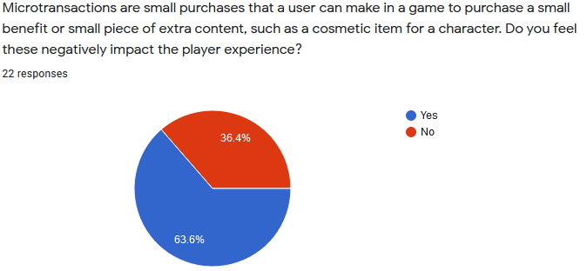
Q15
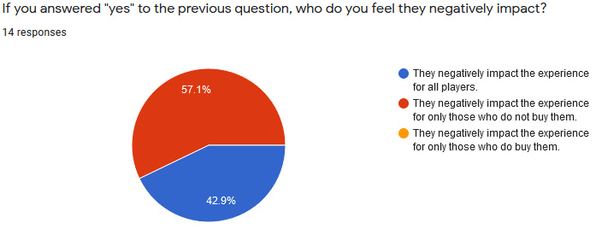
Q16
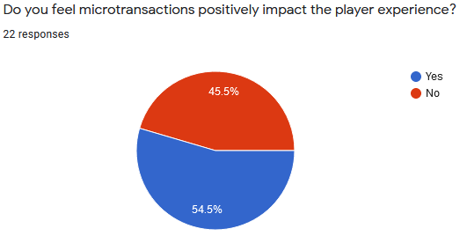
Q17
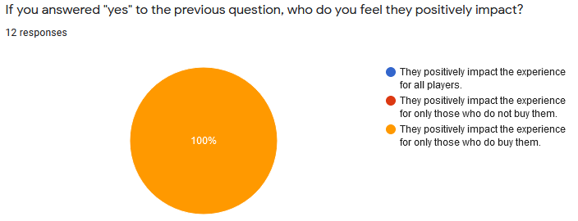

Q18
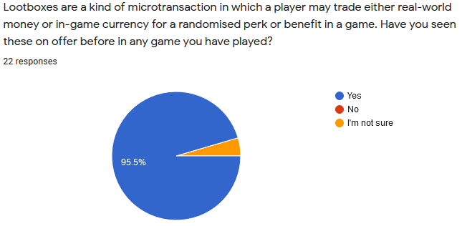
Q19
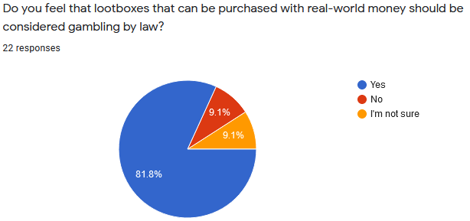
Q20
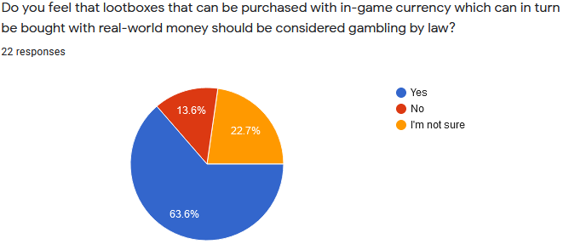

Q21
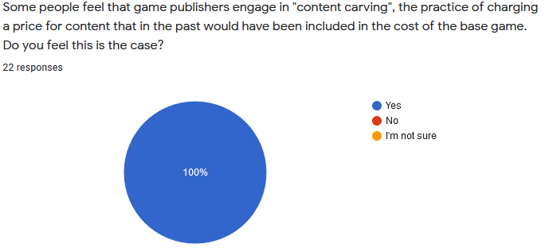
Q22
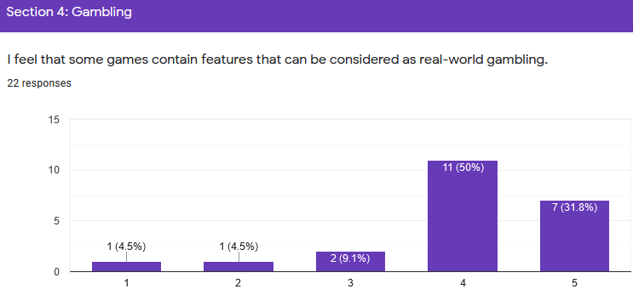
Q23
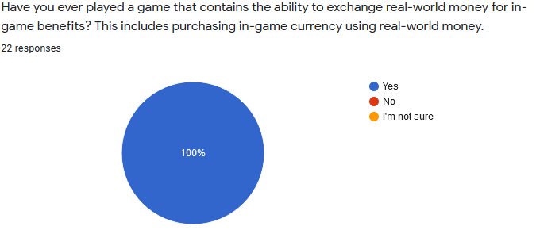

Q24
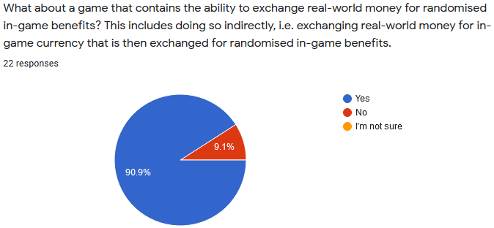
Q25
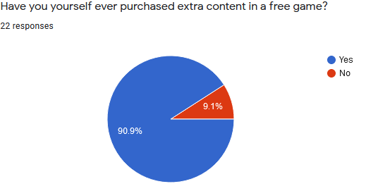

Q26
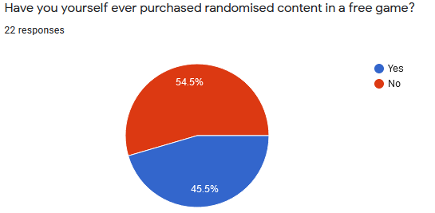
Q27
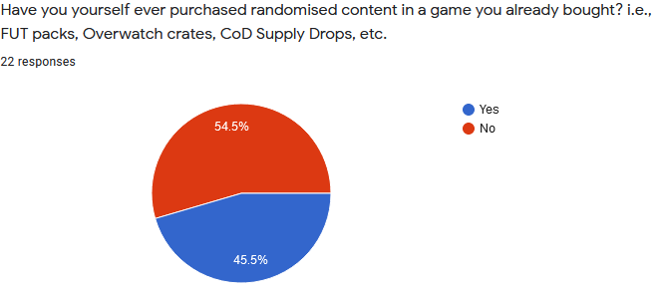

Q28
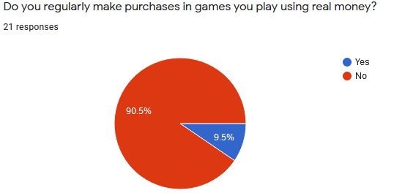
Q29
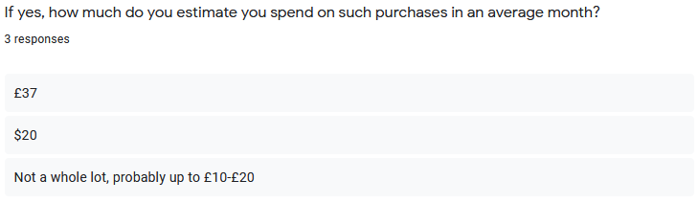

Q30
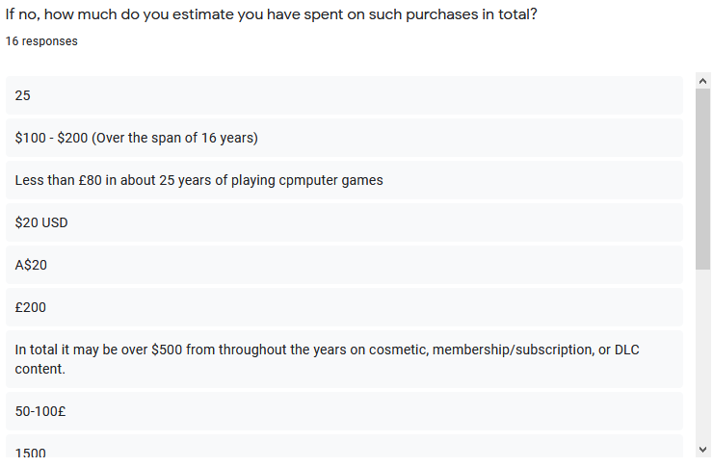
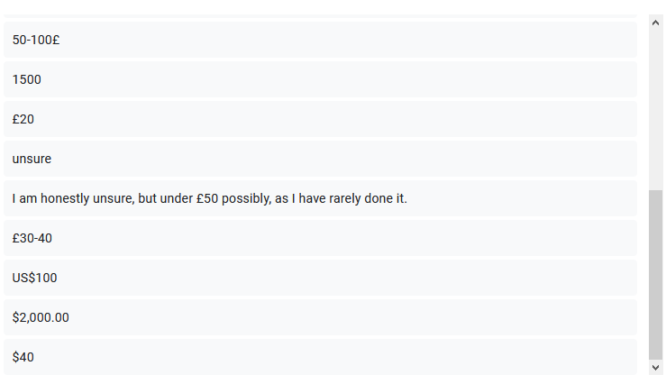

Q31
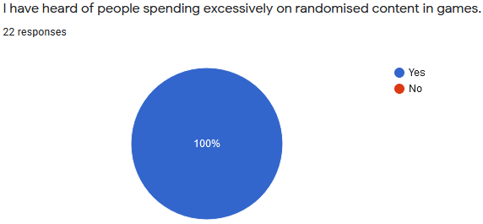
Q32
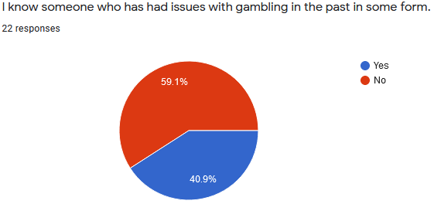
Q33
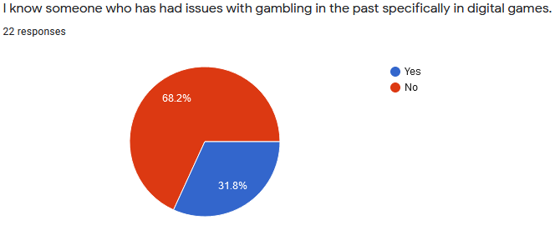

Q34
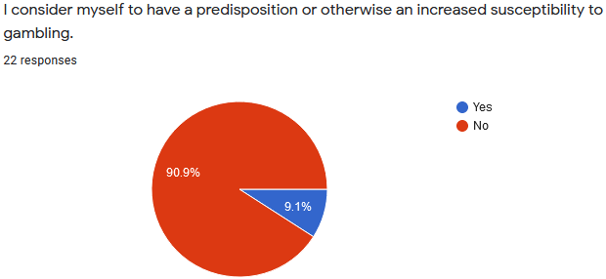
Q35
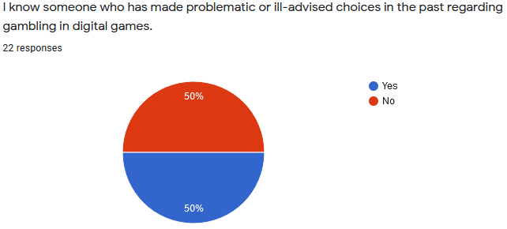
Q36
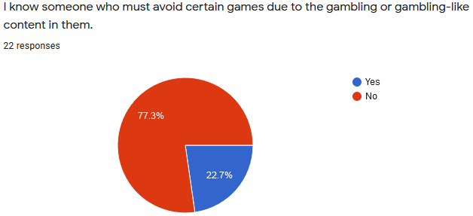

Q37
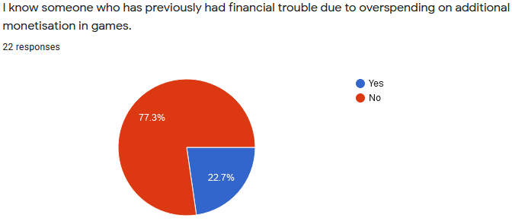

APPENDIX G – USER TESTING FINDINGS
This appendix will show the questions given in the user testing form distributed to the testers. Some questions have been omitted as they were requests for elaboration that received no responses.
Q1
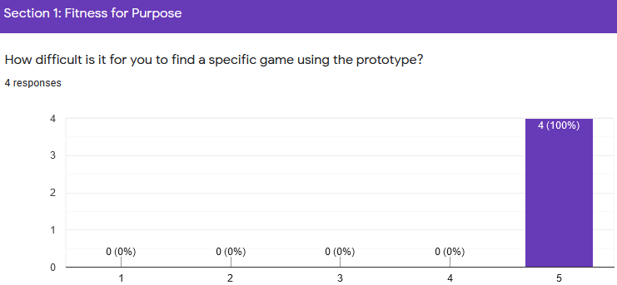Q2
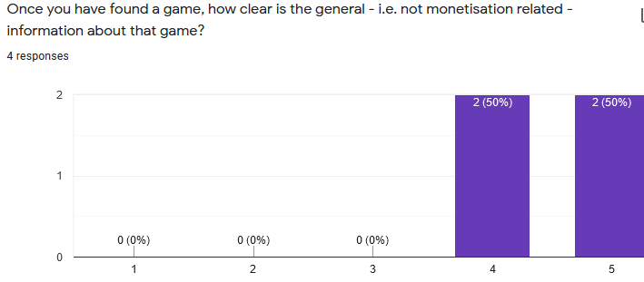

Q3
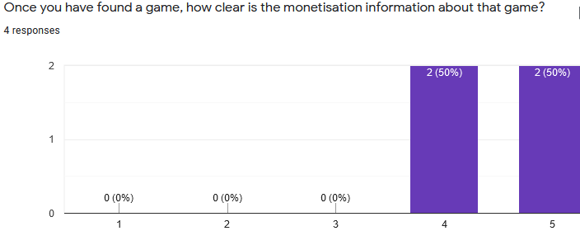

Q4
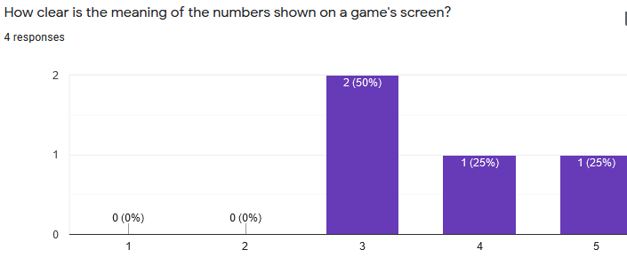Q5
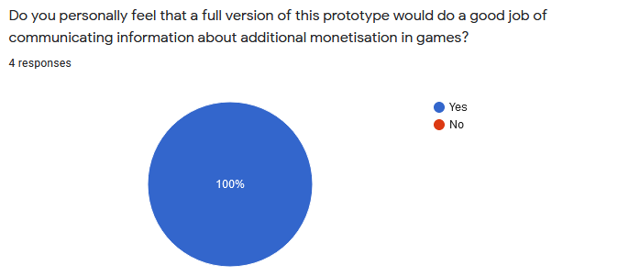

Q6
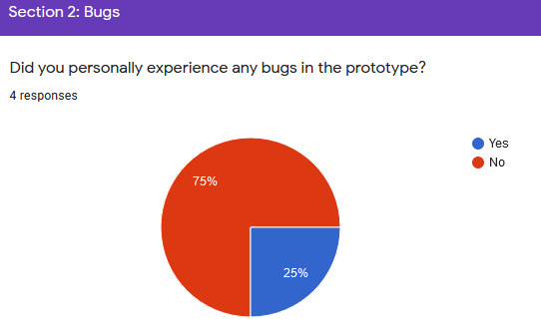

Q7
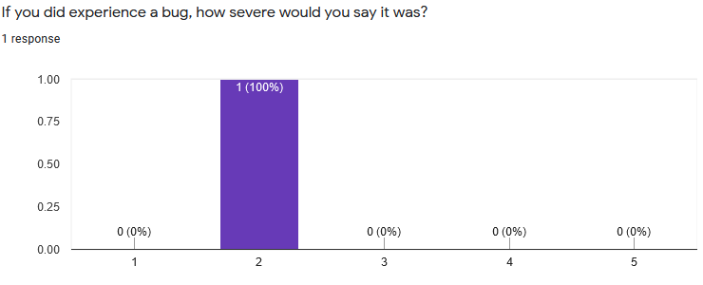

Q8
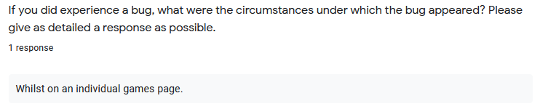

Q9
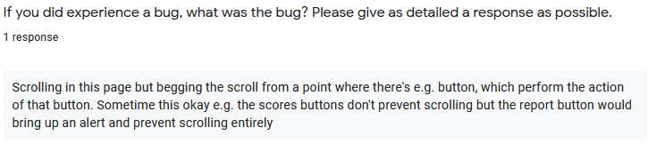
Q10

Q11
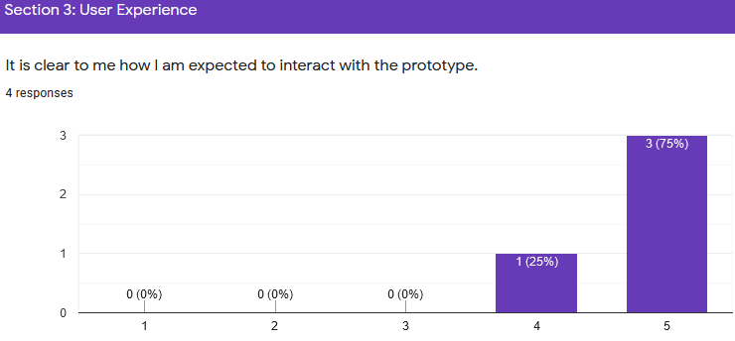
Q12
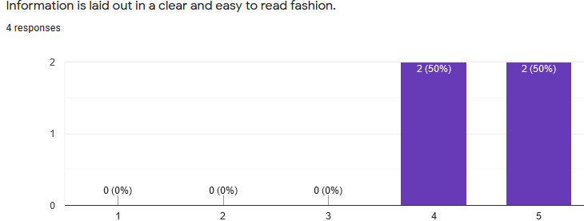

Q13
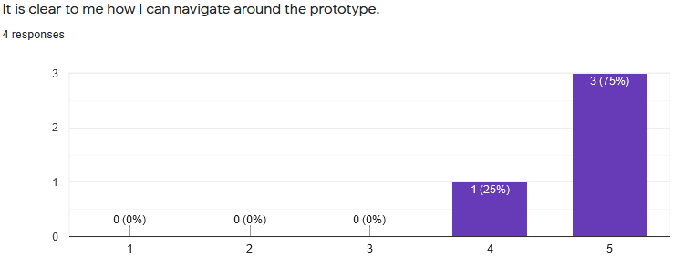
Q14
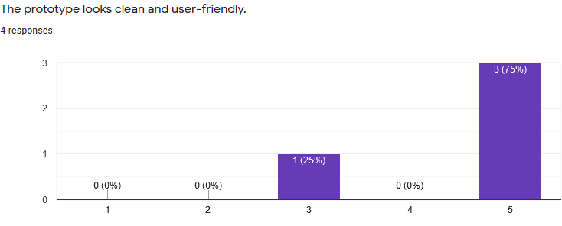
Q15
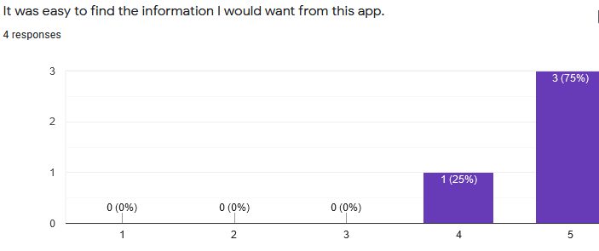

Q16
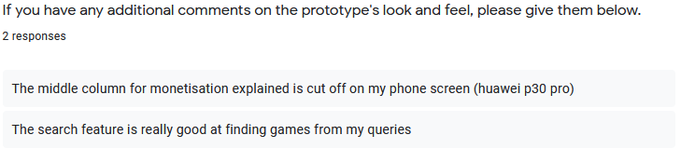
Q17
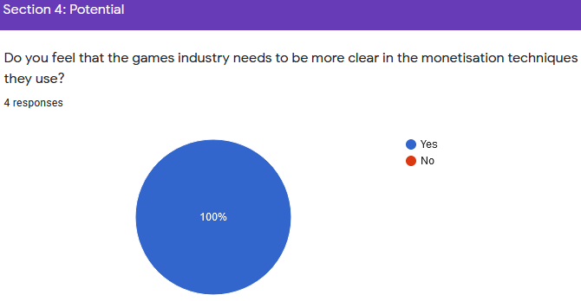
Q18
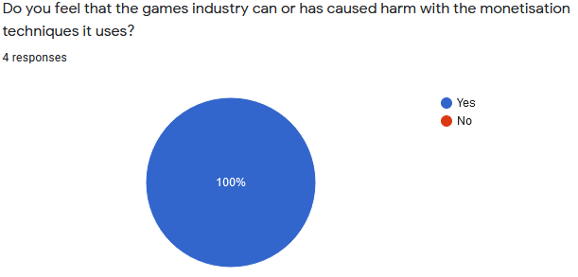

Q19
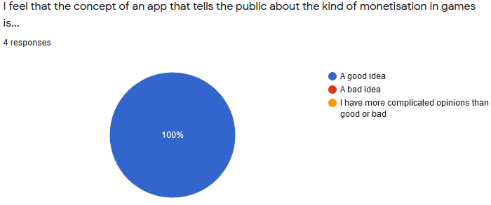
Q20
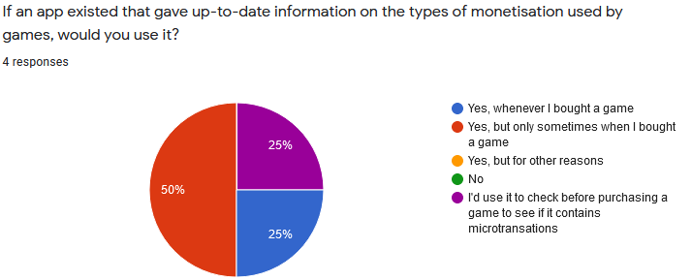
Q21
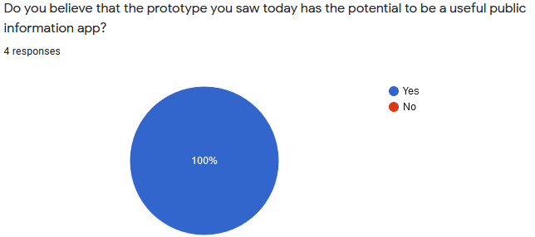

Q22
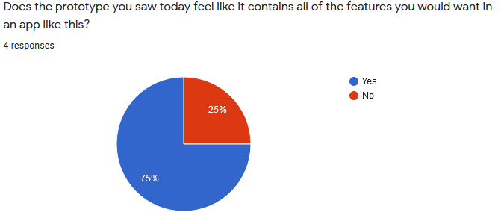
Q23
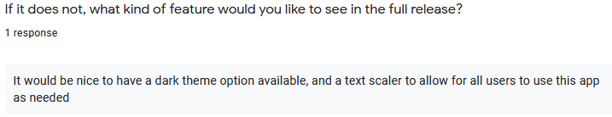

APPENDIX H – LARGE FILE CONTENTS
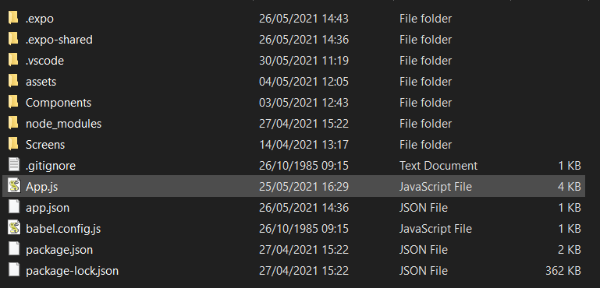
Much of the Large File Submission contains build and configuration files. The most important files are those in the Components and Screens folders as well as the App.js file.
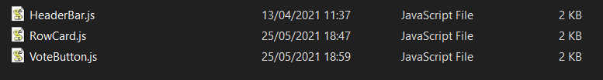
Contents of the Components folder above.
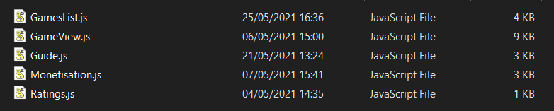
Contents of the Screens folder above.

